**Project Report**

**On**

**“Student Management System”**



As partial fulfillment for the degree of

**Bachelor of Computer Application**

**At**

**K.S.K.V. Kachchh University,**

Bhuj.

(March - 2021)

**Submitted by:**

[DharmanshuAgravat (18BCA001)

DevarshAntani (18BCA002 )

Mayank Rathod (18BCA040 )]

Dhiraj Solanki Mr. Archit A. Vohra Mr. Chintan P. Morabia

Project Guide I/c. Principal Director

**SANSKAR INSTITUTE OF MANAGEMENT & INFORMATION TECHNOLOGY**



**CERTIFICATE**

This is to certify that the project entitled “Student Management System” is a bonafide work carried out by DharmanshuAgravat (18BCA001), DevarshAntani (18BCA002), Mayank Rathod (18BCA040) for the degree of Bachelor of Computer Application at **Sanskar Institute of Management & Information Technology, Bhuj, Gujarat**.

To the best of our knowledge and belief, this work embodies the work of candidates themselves, has duly been completed, fulfills the requirement of the ordinance relating to the Bachelor degree of the university and is up to the standard in respect to content, presentation and language for being referred to the examiner.

Dhiraj Solanki

Project Guide

ACKNOWLEDGEMENT

First of All, We are very thankful to the authority of the Indrabai Girls High School for allowing us to work for them. We would like to take this opportunity to express our heart full gratitude to them.

We would like to thank all those people who helped us directly or indirectly to complete our project. Whenever we found our self n problem our all faculties encouraged us and boosted our moral to accomplish this project.

Last but not least, We would like to express our gratitude to those friends or faculties who directly or indirectly helped in final year project.

DharmanshuAgravat (18BCA001)

DevarshAntani (18BCA002)

Mayank Rathod (18BCA040)

|  |  |  |  |  |
| --- | --- | --- | --- | --- |
|  |  |  | **INDEX** |  |
| **Sr.No** |  |  | **Topic** |  |
| 1. | Introduction…………………………………………………… | | | [1page] |
| 2. | OrganizationProfile………………………………………… | | | [1page] |
| 3. | ExistingSystem……………………………………………… | | | [1page] |
| 4. | Problemareas andneed forthenewsystem………… | | | [1–3pages] |
| 5. | Proposedsystem | |  |  |
|  | 5.1. | Developmenttoolsandtechnologiesused…. | | [1page] |
|  | 5.2. | Businessprocessdescription(TheoryorDiagram) | | [1page] |
|  | 5.3. | SystemFeatures | |  |
|  |  | 5.3.1. | Assumptions(ifapplicable)………………… | [1page] |
|  |  | 5.3.2. | DataFlowdiagram..........................………. |  |
|  |  | 5.3.3. | Usecasediagram…………. |  |
|  |  | 5.3.4. | Activitydiagram………… |  |
|  |  | 5.3.5. | Entity-relationshipdiagram……………….. |  |
|  |  | 5.3.6. | DataDictionary………… |  |
|  |  | 5.3.7. | Screen Layouts…………. | [1page] |
|  |  | 5.3.8. | ReportLayouts…………. |  |
|  |  | 5.3.9. | CodingSystem(ifapplicable)………….. |  |
| 6. | ProposedEnhancement | | | [1Page] |
| 7. | Conclusion | |  | [1Page] |
| 8. | Bibliography | |  | [1Page] |

Name :- Indrabai Girls High School.

Address :- Opp. Bus Station Rd, Ghanshyam Nagar, Bhuj, Gujarat 370001.

Indrabai Girls High School is a government school established in ______ in BHUJ-KUTCH . It consists of class 9, 10, 11 and 12 with Science, Commerce, Arts and Home Science streams.It is a well knownorganization for its quality education.

Currently firm is using Registersand Excel files to manage students and all school's data.They Create Different Registers for Different classes to manage data. There is no dedicated system for data management .

Project Definition:-

This system is prepared for a Student Management System which deal with student data.

This system will allow admin to manage student and teacher data.

DFD LEVEL 0

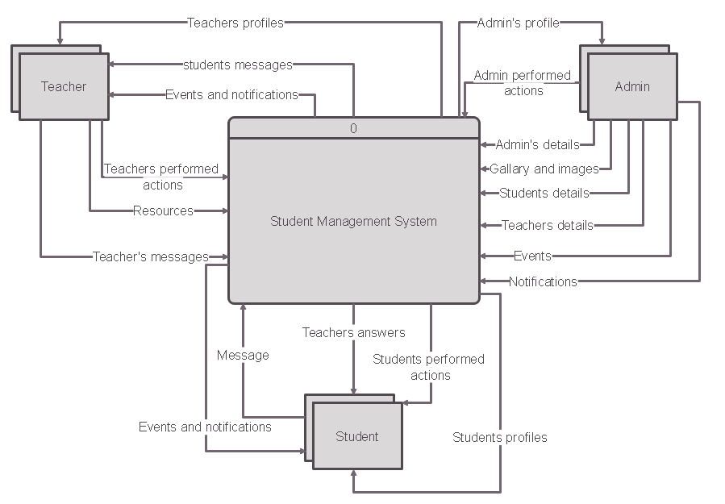

DFD LEVEL 1

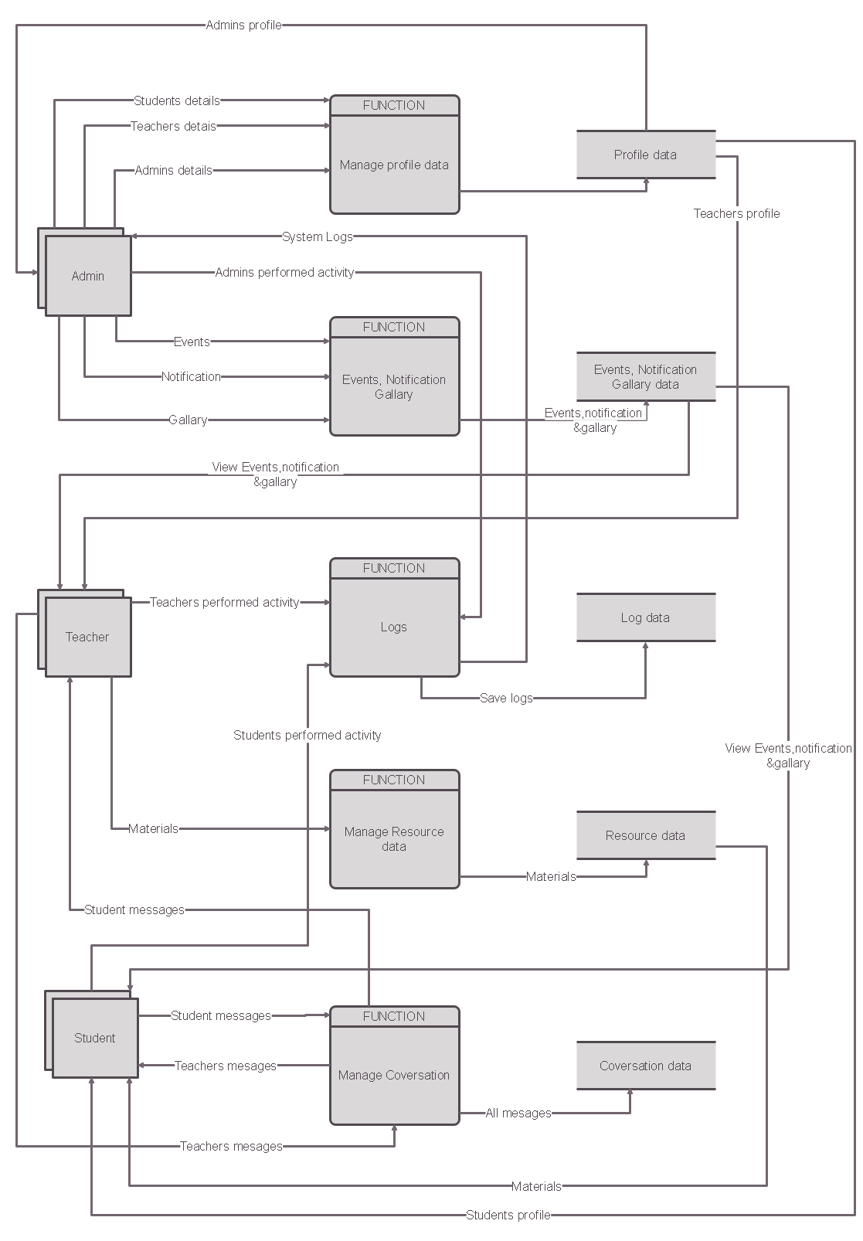

USECASE DIAGRAM

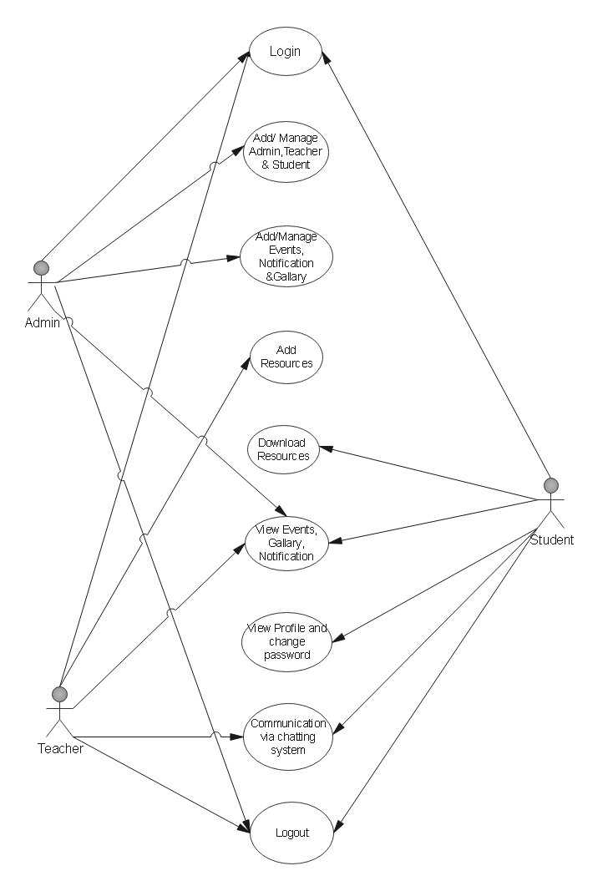

Admin’s Activity Diagram

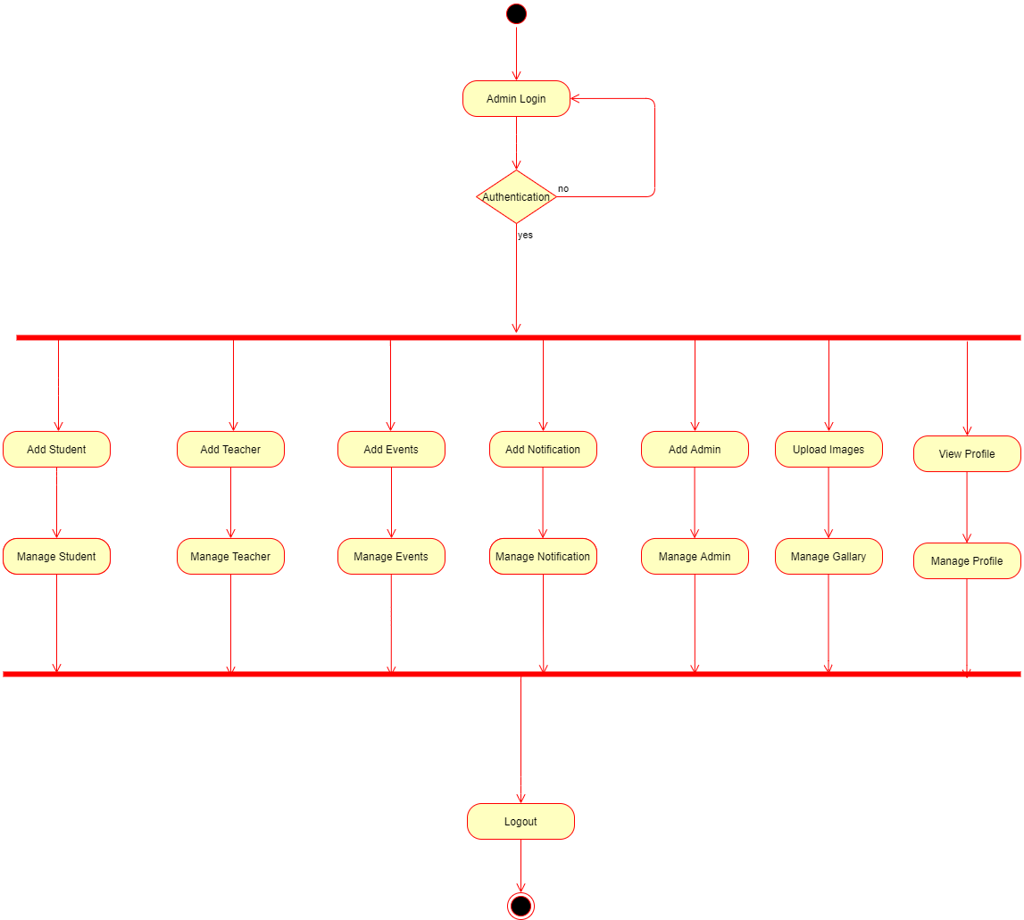

Teacher’s Activity Diagram

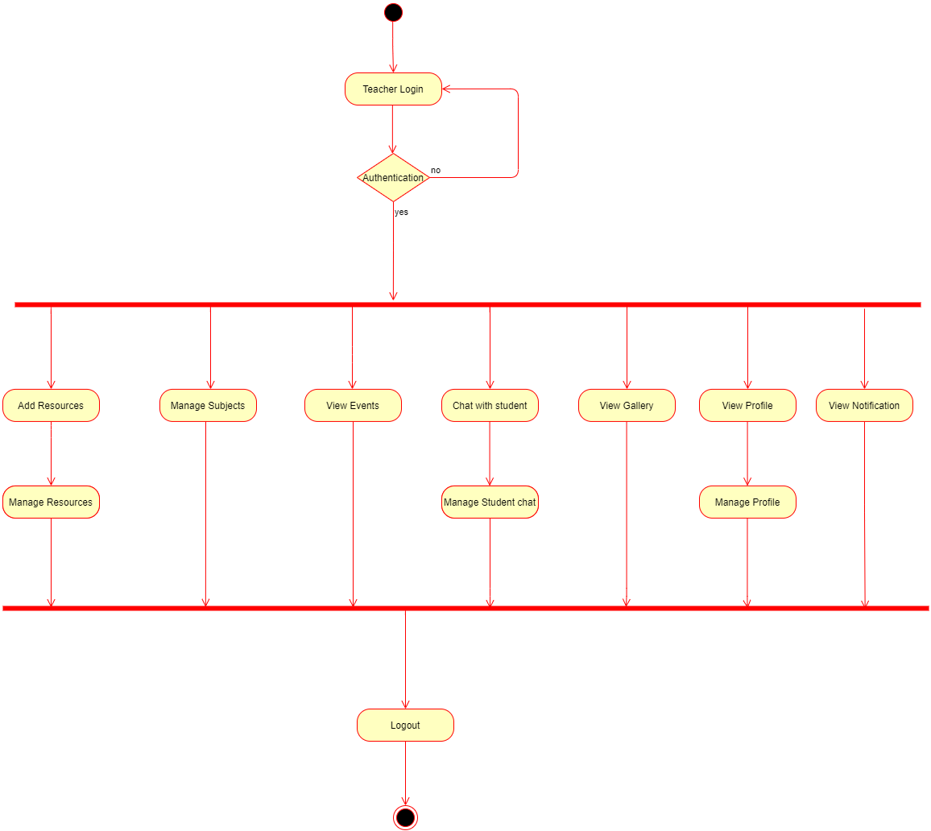

Student’s Activity Diagram

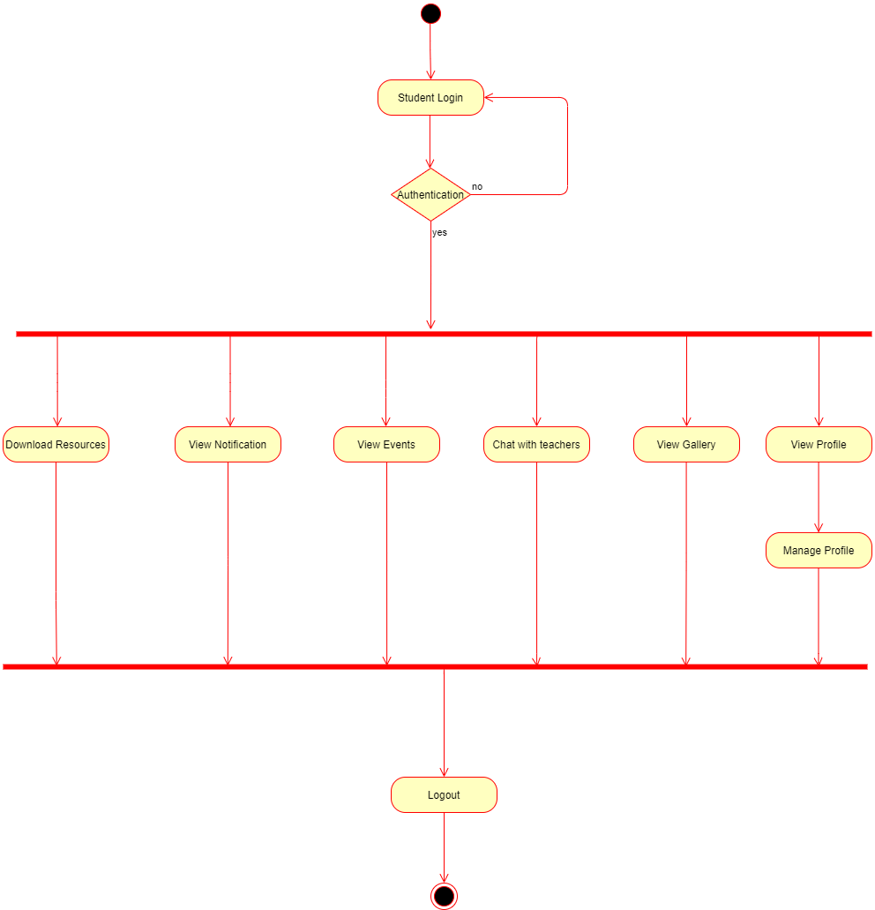

Entity Relationship Diagram

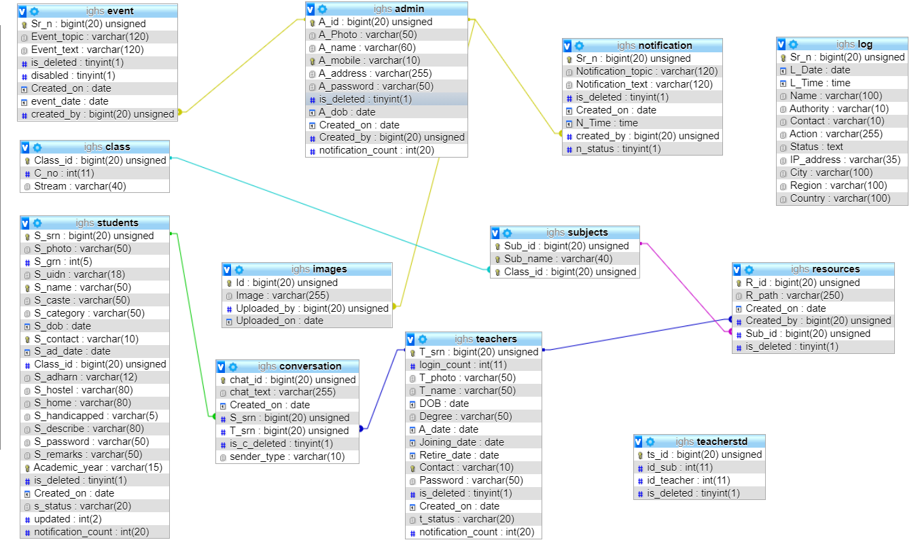

**System Snapshots**

* There are total 3 sections in our system .
* Admin Panel
* Teacher Panel
* Student Panel
* Admin Panel is most important part of our project and it consist of most featured to manage student's, teacher's and other admin's data.
* Teacher Panel enables teacher to send study material to students and receive message from student and send reply to those messages .And also teachers can see images, event information, And notifications uploaded by admin.
* Student Panel allows students to download study material from site uploaded by their subject teachers, Students can message teacher to solve their query. And also students can see images, event information, And notifications uploaded by admin.

**Admin Panel**

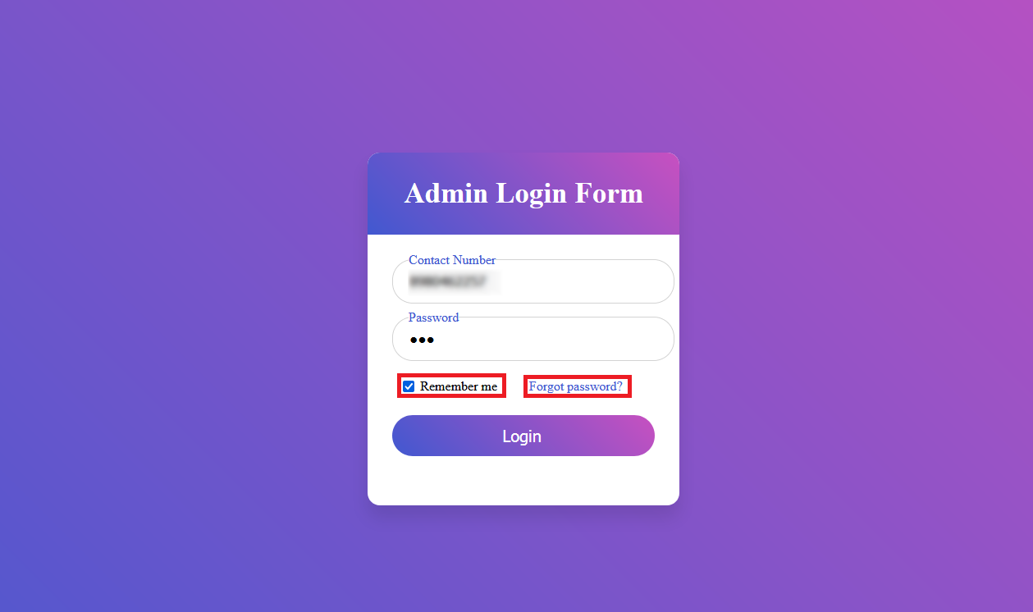

**Image- 1**

* This is the Login page for Admin.
* Admin will need to enter their registered mobile number and their password in order to login to their account.
* They can choose to save their details by selecting "Remember me " checkbox and if they want to delete their details they can deselect checkbox next time they login
* If admin forgot his/her account password they can click on "Forgot password" and receive an OTP (One Time Password), to the mobile number registered in their account and reset the password.

1. Step after clicking on "Forgot Password". Enter mobile number in the given text box and click on "Get OTP" to receive OTP.

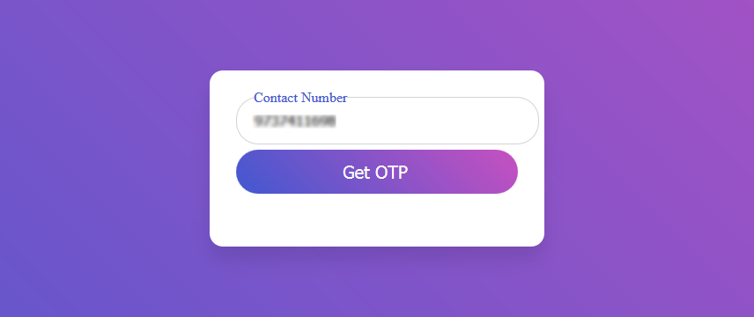

**Image-1.1**

1. User will receive an OTP on the mobile number , enter that code in next page as below. And click on Verify to confirm code .

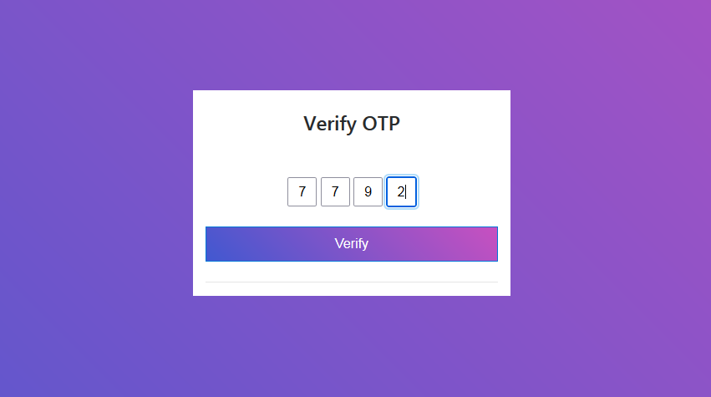

**Image-1.2**

1. If OTPcode is correct User can reset password in next page .And Submit to login into their account.

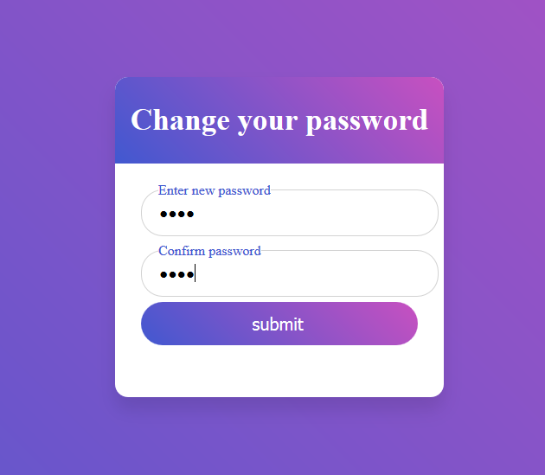**Image-1.3**

**Admin Dashboard**

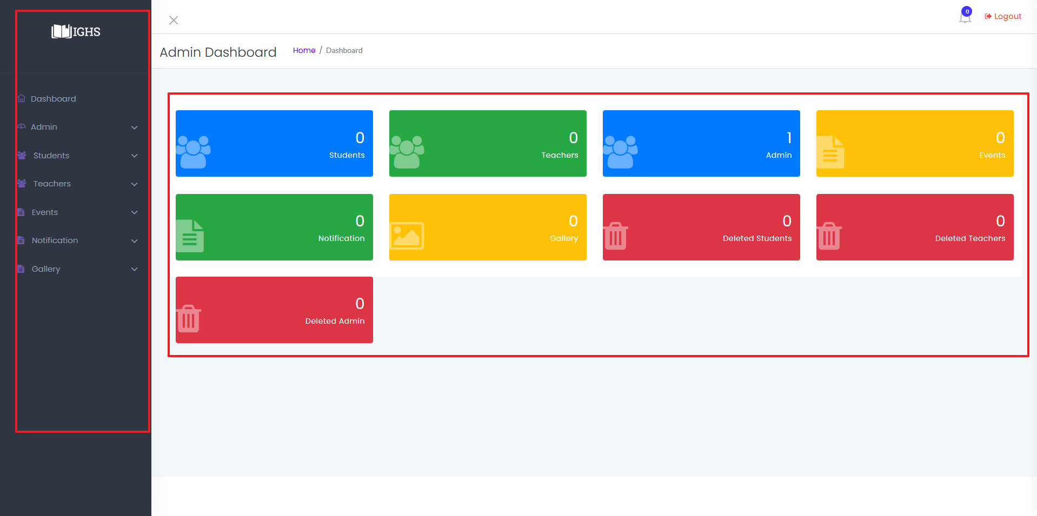

**Image-2**

* This is Admin Dashboard where Admin can access all features to manage every data .
  1. Admin can see how many students, Teachers , Admins, Events , Notifications, Images in Gallery, Deleted students ,Deleted teachers ,Deleted admins are in system.
  2. On left side of the screen admin can use Side-bar to easily navigate through system.

**Admin : Manage Student Data**

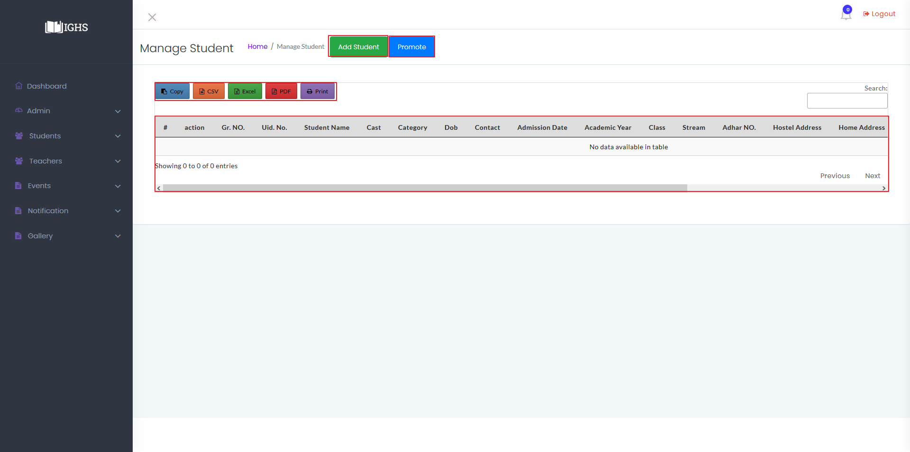  
**Image-2.1**

* Admin can access this page ( Manage Student Window) by clicking on "Students ", on image number 2.

**ADD STUDENTS :-**

* In image 2.1 the table is empty because there are no data in system yet, To add a student data click on "Add Student" highlighted with red box in image 2.1.

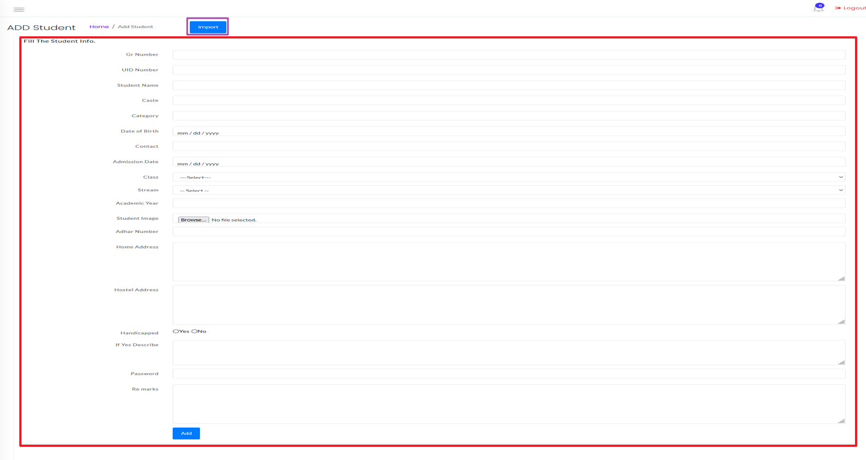

**Image-2.2**

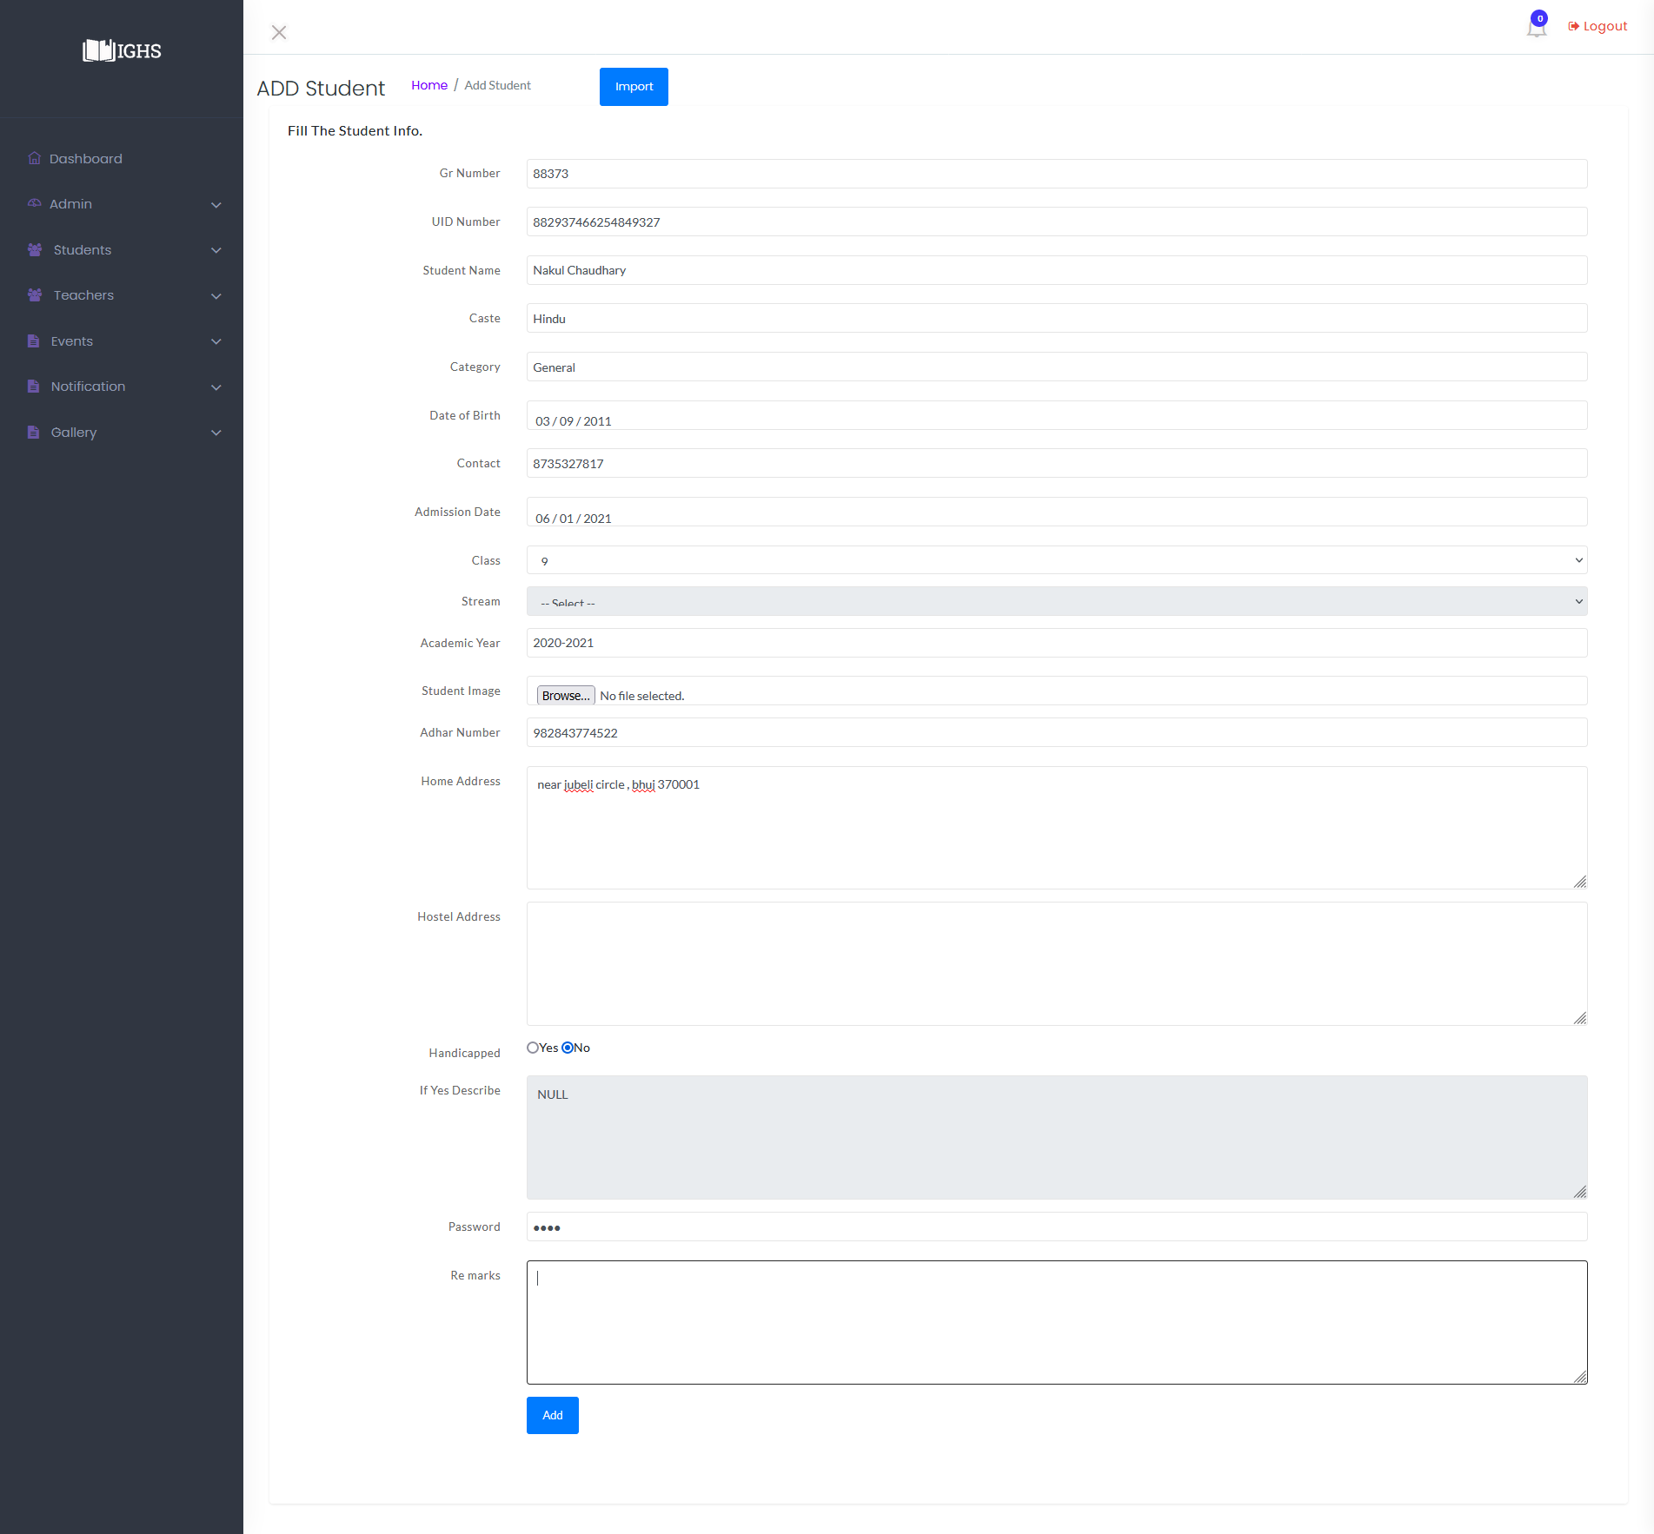

**Image-2.2.1**

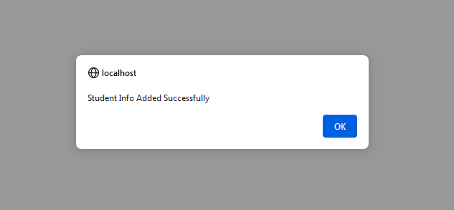

**Image-2.2.2**

* Admin can Enter a single Student at a time by filling up the form highlighted with red box, and click on "Add" button available at end of form .
* After filling the form ,it will look like image-2.2.1, And After submitting it if the data is proper then data will be stored and generate an Success alert shown in image-2.2.2.
* If data is not valid then it won't let admin to submit form.
* To Add multiple student data at a time then click on "Import" button highlighted with purple box in image-2.2.

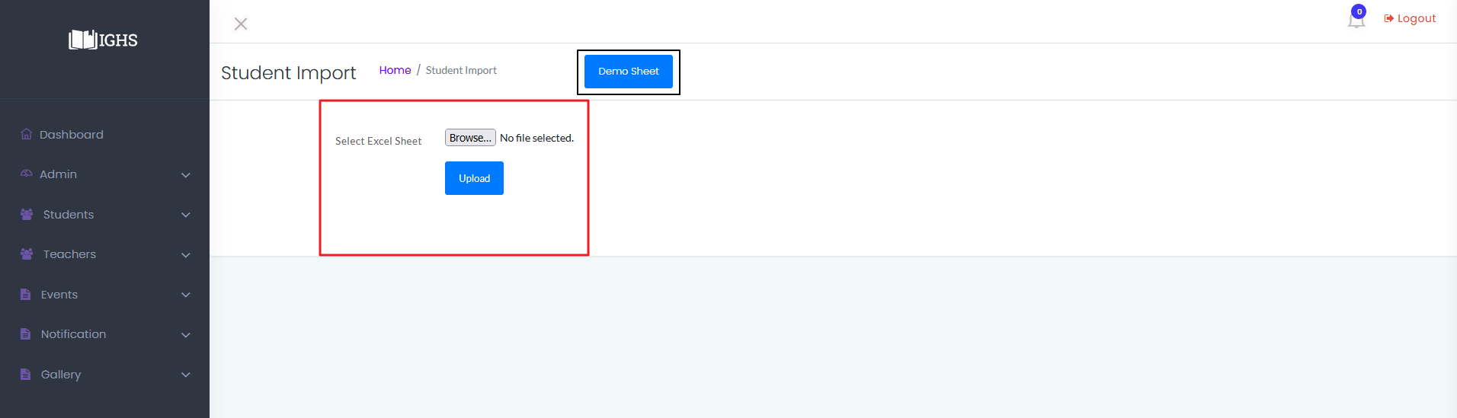

**Image-2.3**

* Then click on "Demo Sheet" highlighted with black box in image-2.3 to download an empty sheet with column names which will look like as Image-2.3.1 as shown below.

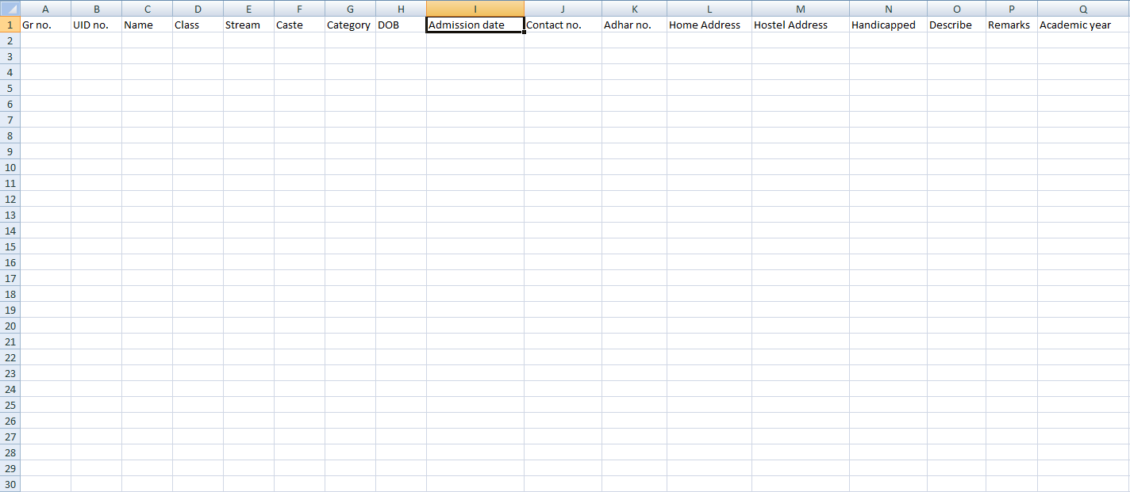

**Image-2.3.1**

* Admin will need to set format column-B and column-K to "Text". And format column-H and column -I to custom date "yyyy-mm-dd".

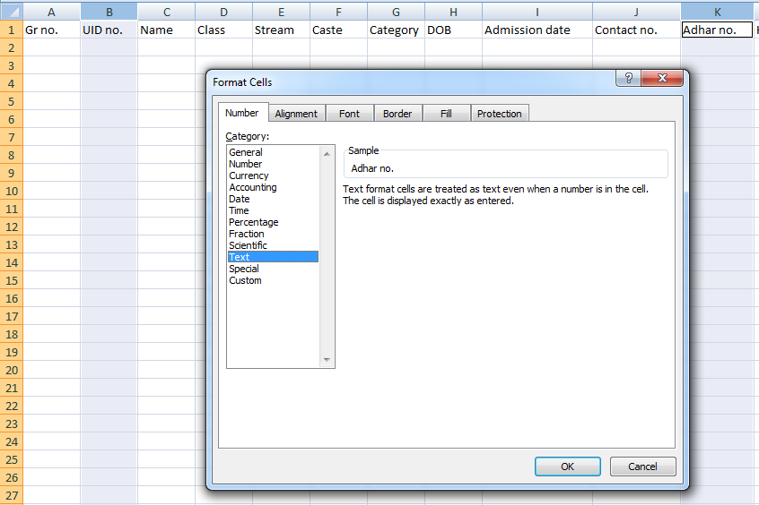

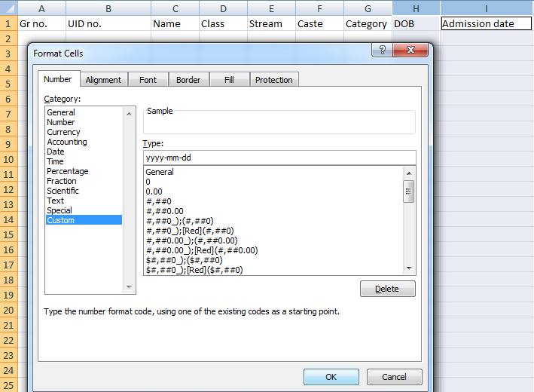

**Image-2.3.2 & Image-2.3.3**

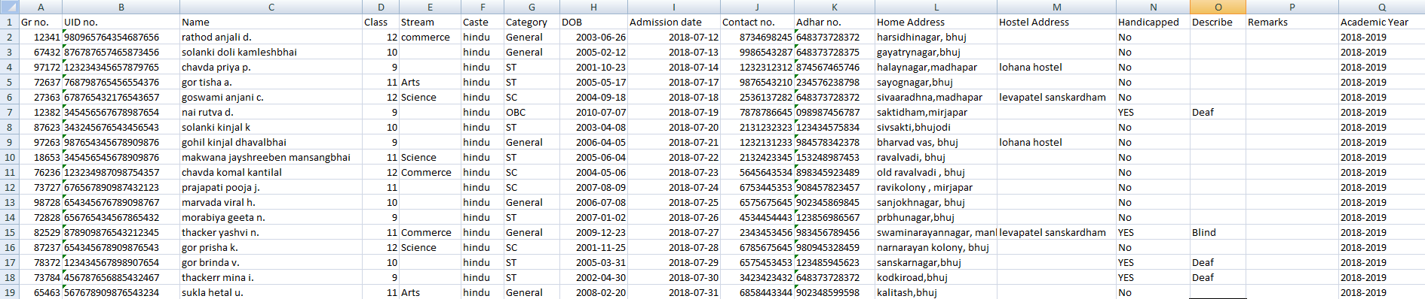

**Image-2.3.2**

* Every column must be filled except column-M ("Hostel Address) and column-P (Remarks) are completely OPTIONAL .
* If student is handicapped then fill "yes" in column-N else fill "no". If student is handicapped then it's description must be filled or system won't let admin to insert data in system.

**To Upload :-**

* After filling up the Excel sheet admin can upload the sheet by clicking on "Browse" highlighted by red box in Image-2.3 and select file to be upload
* If file is successfully uploaded it will show a success message on screen. And if any error occurs it will show error on screen.

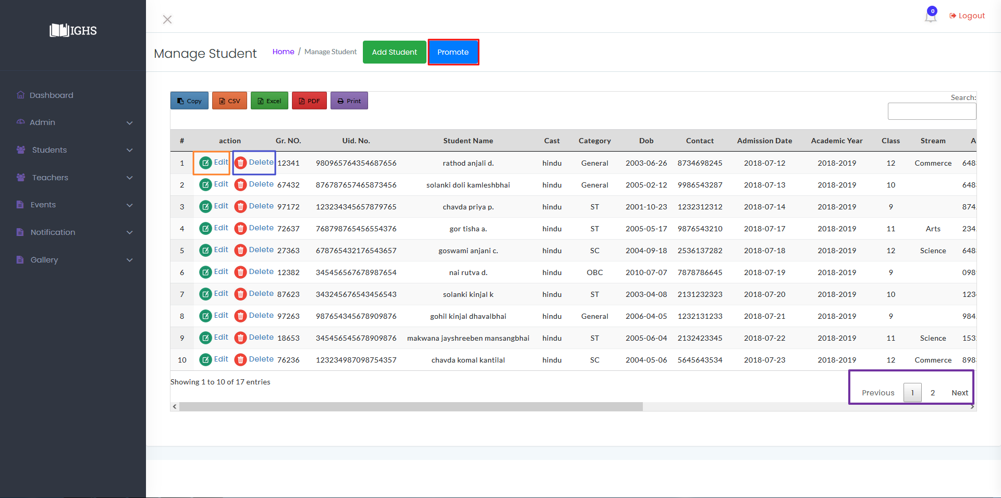**Image-2.4**

* After a successful import "Manage Student" tab would look like as shown in Image-2.3.3 .

**PROMOTE :-**

* Admin can promote students to next class by clicking on "Promote" button highlighted by red box in Image 2.4 .

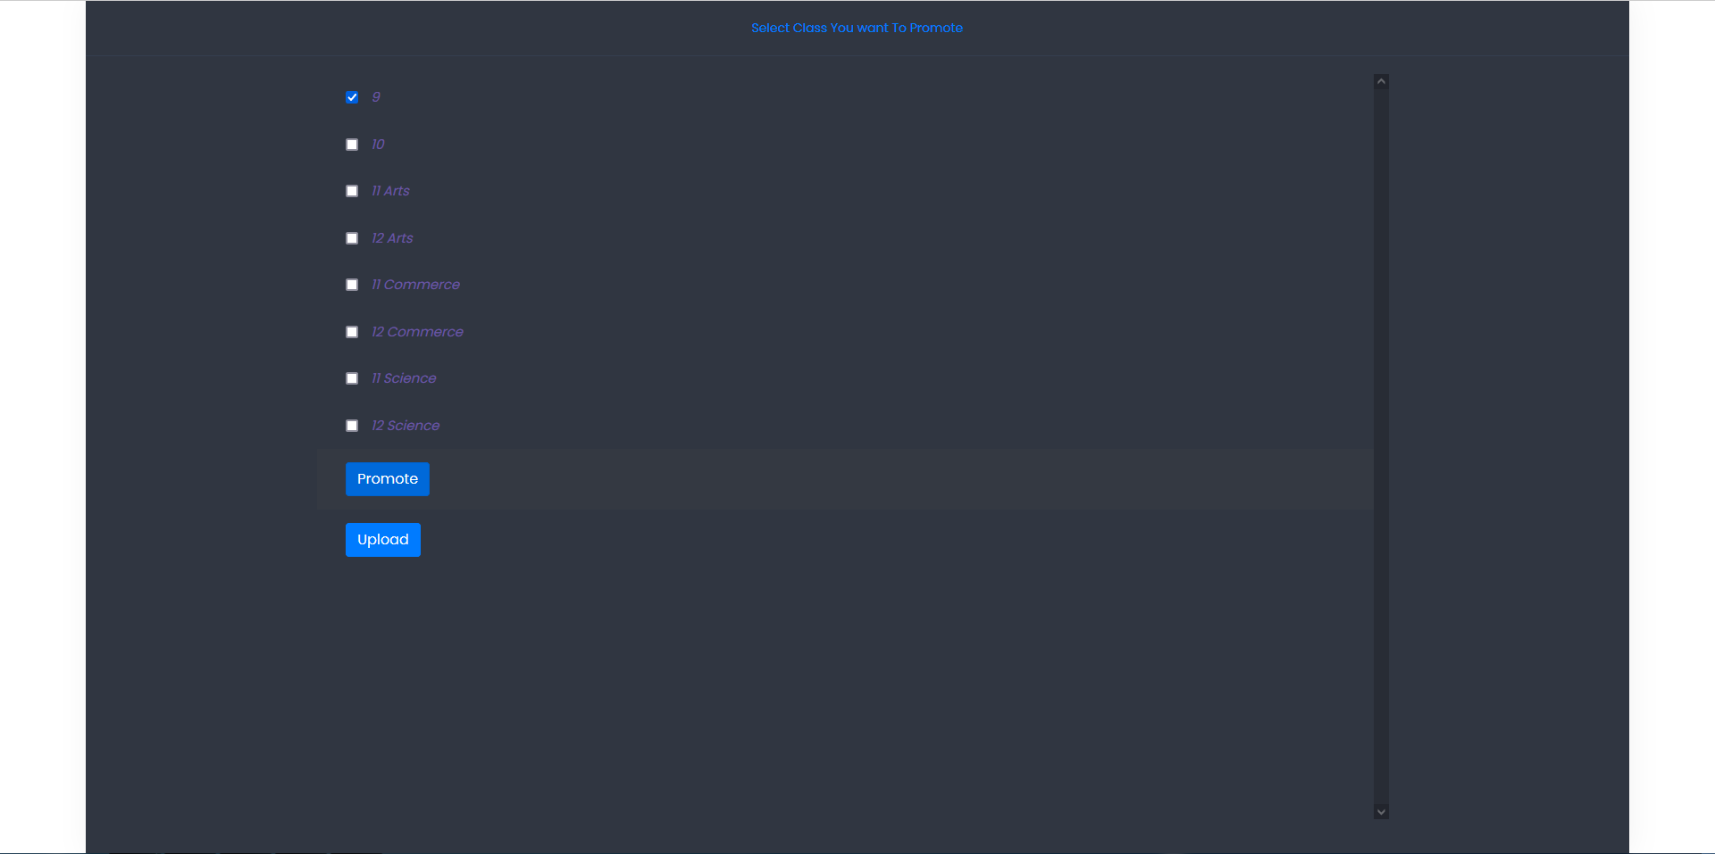

**Image-2.4.1**

* After clicking on "Promote" a list of class appears on screen as shown in image-2.4.1.
* Admin can select which classes he/she wants to promote and click on "Promote" button available at the end of list, The System will generate an Excel sheet containing students' details whose classes are selected by admin .



**Image-2.4.2**



**Image-2.4.3**

* Admin must change Every students "Class" and "Academic Year" in order to promote Students to next class .
* Excel sheet in Image 2.4.2 is system generated sheet and Excel sheet in Image 2.4.3 is updated by admin .Admin can also change other details as per requirement.

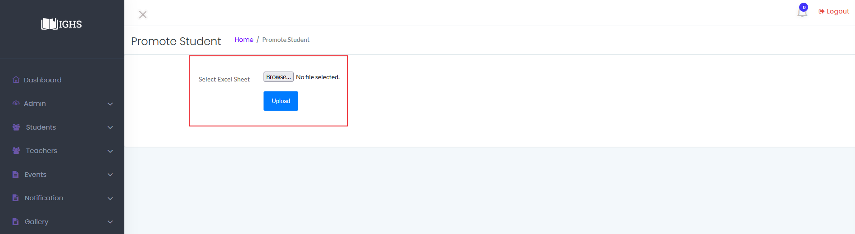**Image-2.4.4**

* Click on "Browse" button highlighted with red box in Image-2.4.4 and upload the updated excel sheet. It will show success message if data is proper else it will show error on screen.

**Edit Student Data : -**

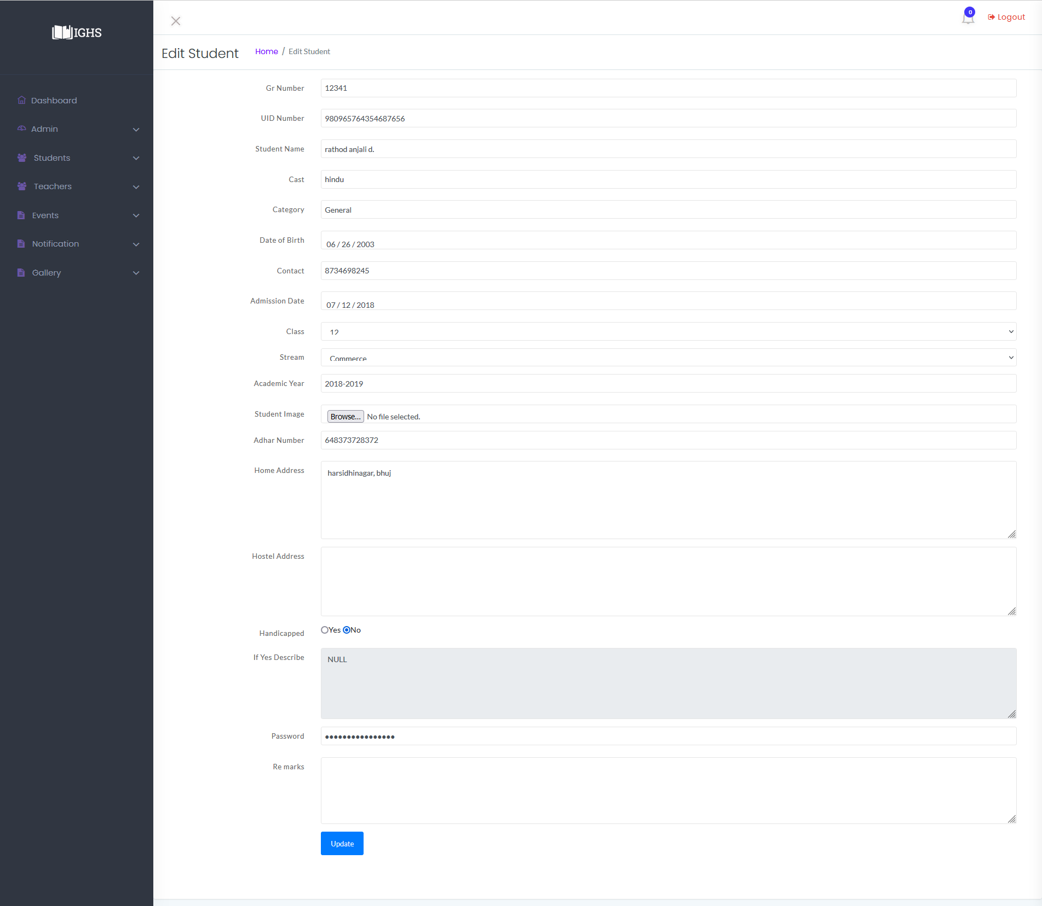

**Image-2.4.5**

* Click on "Edit" button highlighted with orange box in Image-2.4 given beside of student details, which will open that students detail in a form format. As shown in Image-2.4.5 .
* **N**ow Edit details as per requirement and click on "Update" button to submit the form and student details will be updated in system with a success message on screen .Or if data is invalid error will be displayed on screen.

**Delete Student : -**

* To delete student data from system click on "Delete" button highlighted blue box in Image-2.4 beside of student details, which will delete that student's details and keep that data in Bin named "Delted Students " where admin can restore that data if needed.

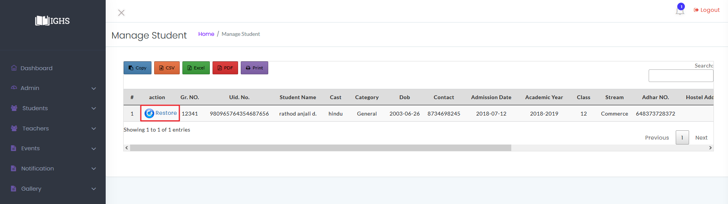

**Image-2.4.6**

**Restore Student Data :-**

* To restore student data click on "Deleted students" from "Admin Dashboard" as shown in Image-2 and it will show list of deleted students as shown in Image-2.4.6 .
* Click on "Restore" icon highlighted with red box in Image -2.4.6 and it will show a success message and restore the student's data .

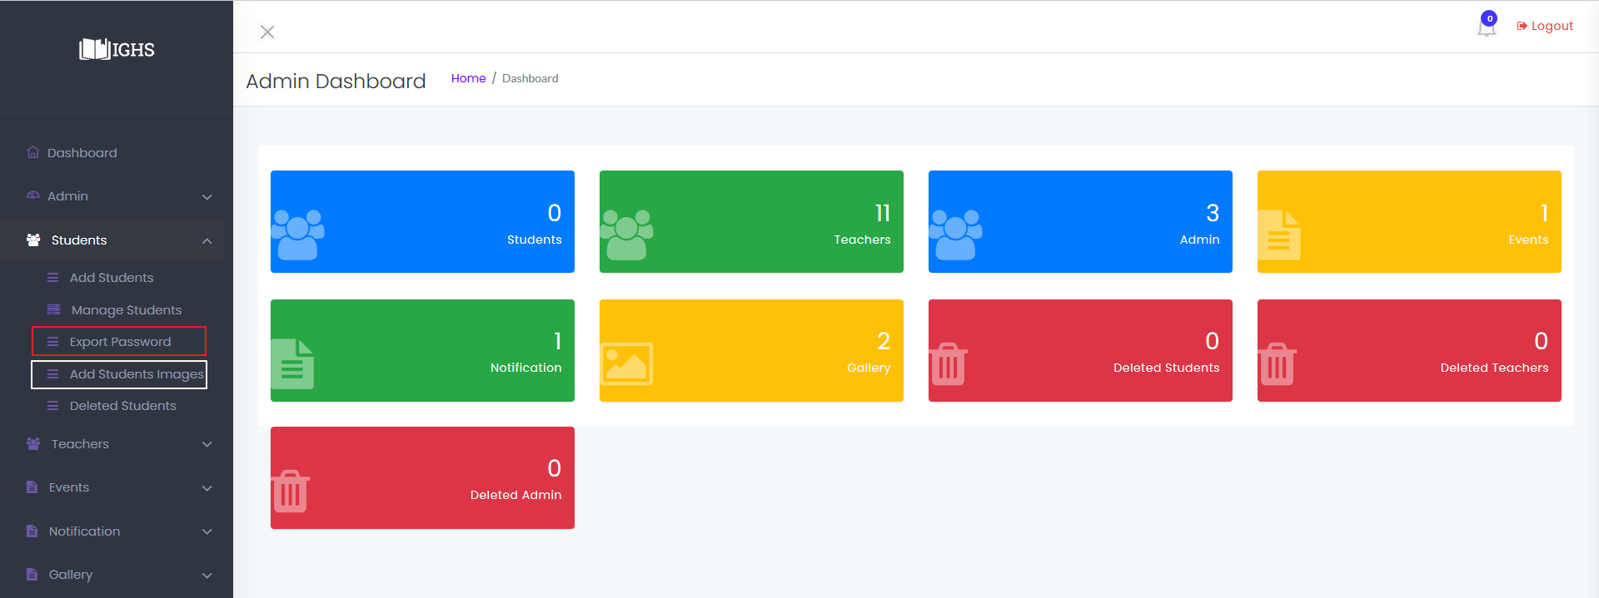

**Image-2.4.7**

**Browse all Data : -**

* To browse all student data admin can use navigation buttons highlighted with purple box at bottom of Image 2.4 .Admin can also search specific data from search option highlighted with red box in image shown below.

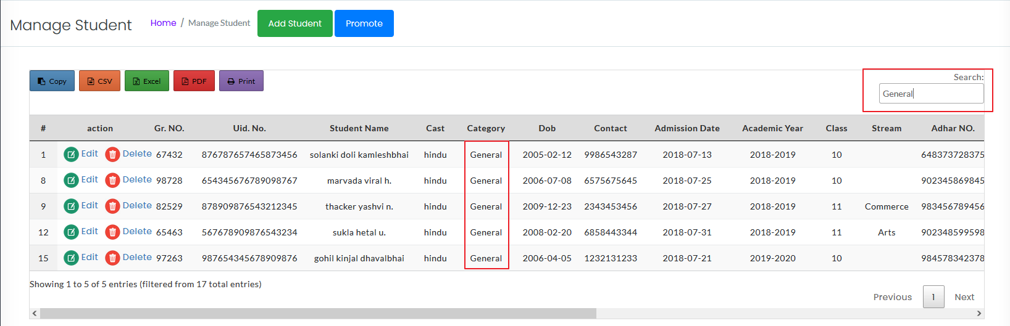

**Insert Student Images : -**

* Click on "Add student images " available in Side-bar highlighted by white box in Image-2.4.7 which will open a window as shown in Image 2.4.8 .

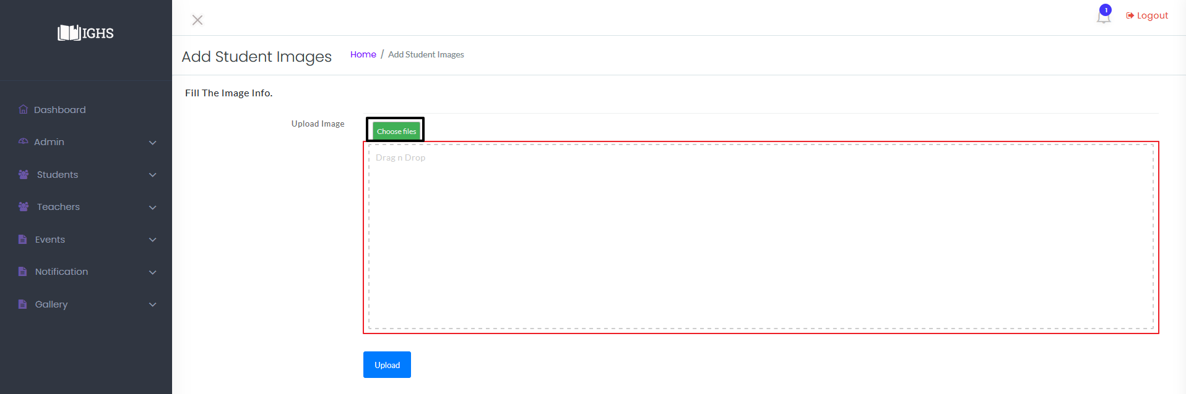

**Image-2.4.8**

* To insert Student Images Admin will be required to manually rename all student' photos with student's GR number .
* Then either click on "Choose file" highlighted with black box in Image-2.4.8 and select all images or drag all images in a light brown box highlighted with red boarder and click on "Upload" button to upload student images to the system.
* Images are only used for profile pictures and also completely optional.

**Export Students' ID-Pass** : -

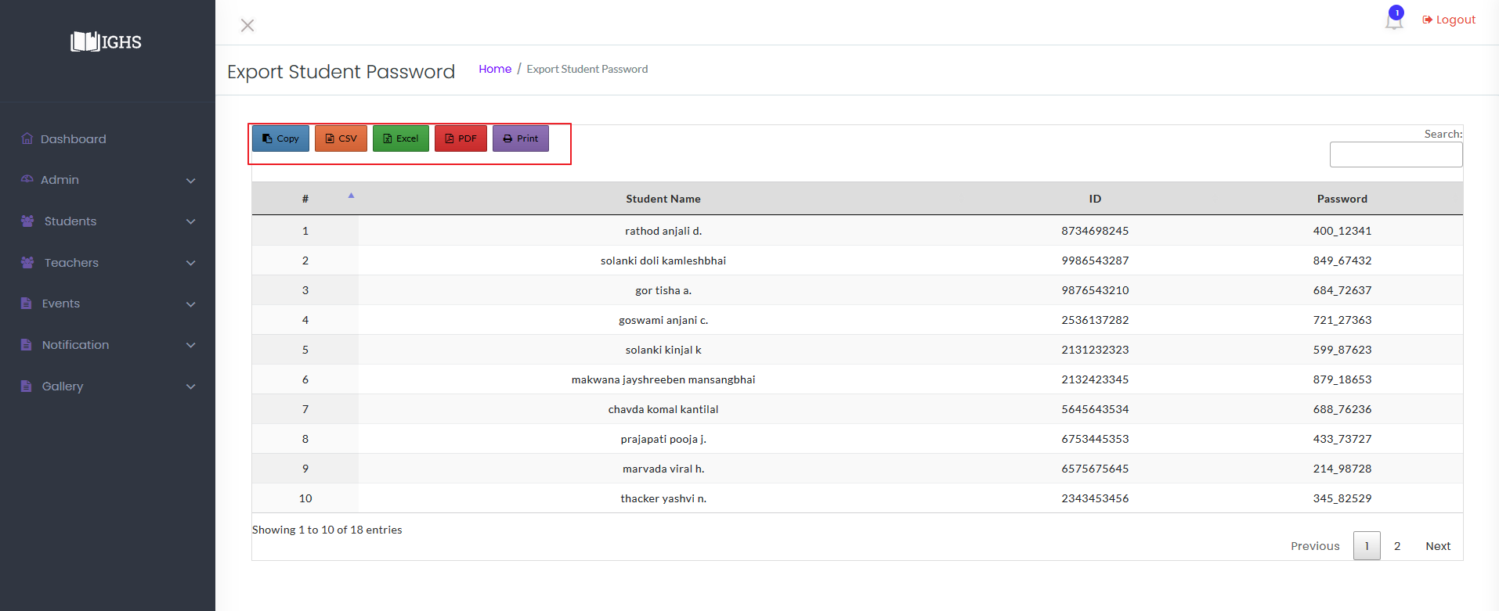

**Image-2.4.9**

* Admin will make all students account so in order to give access to students follow steps as below :-
* Click on "Export Password" option available in side-bar highlighted with red box in Image-2.4.7
* After clicking on "Export Password" a window with students name ,contact number and their passwords as shown in Image-2.4.9.
* To export them either tool can be used from highlighted red box in Image-2.4.9 .

**ADMIN : MANAGE TEACHERS**

* All Features of manage teachers are same as manage students and its snapshots are as below :-

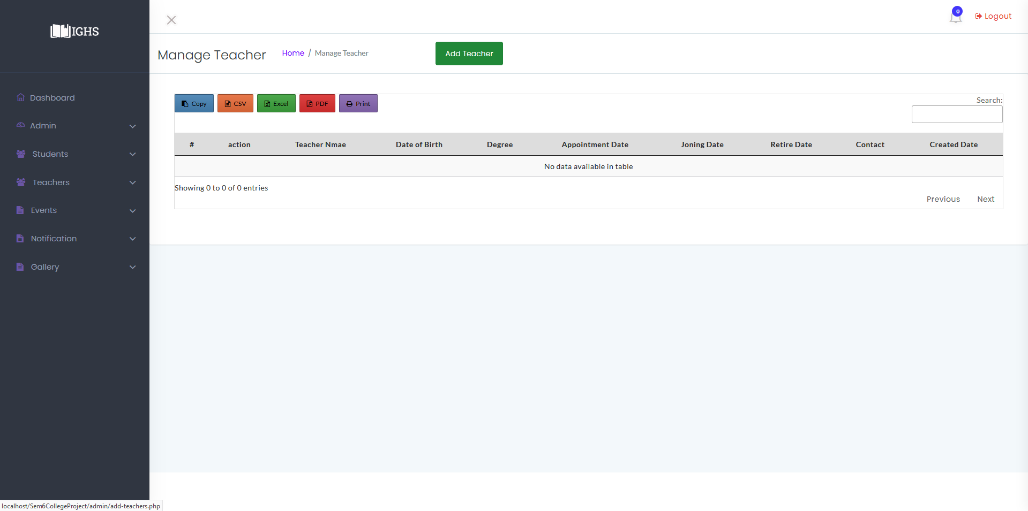**Image-3**

**Add Teacher** 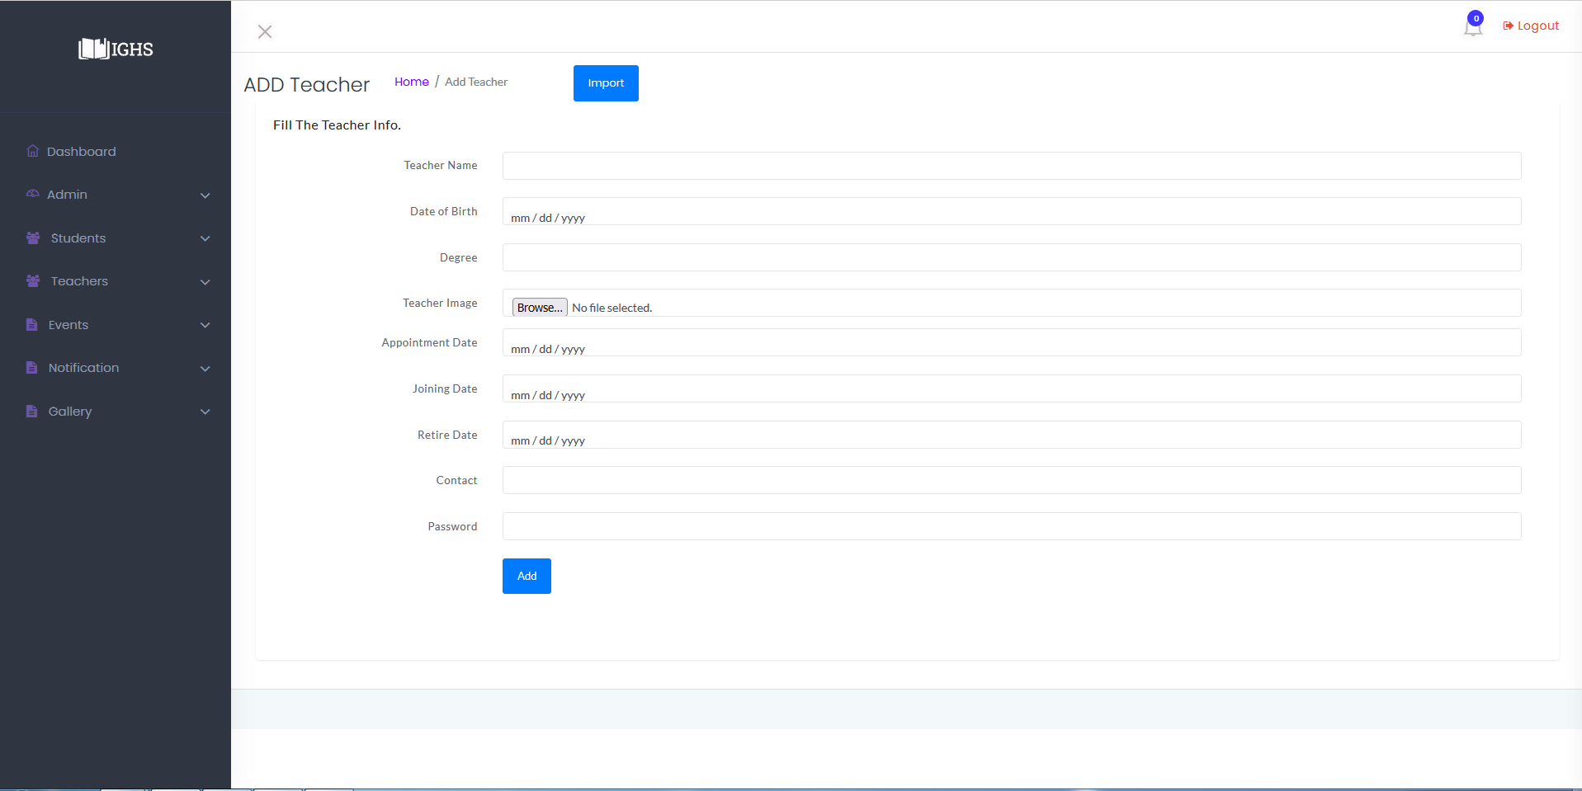

**Image-3.1**

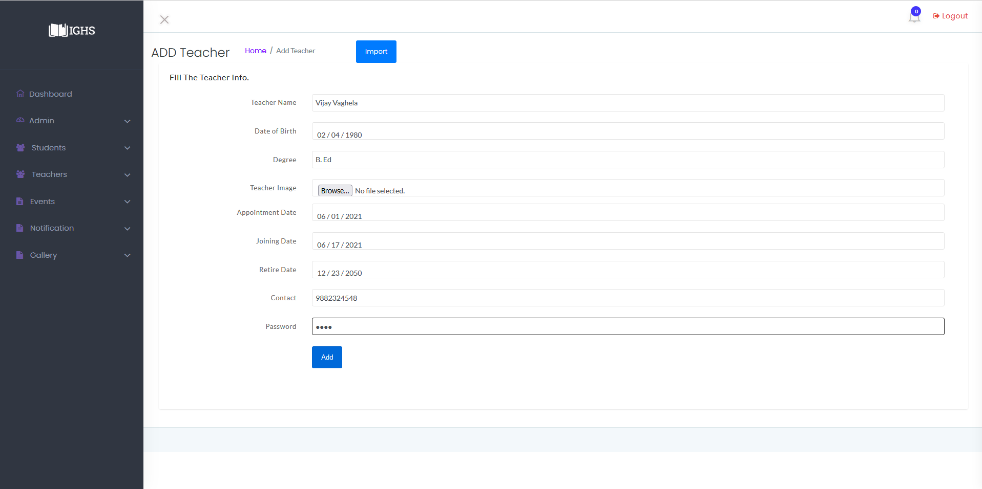**Image-3.1.1**

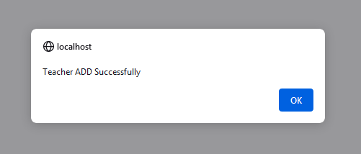

**Image-3.1.2**

**IMPORT TEACHER**

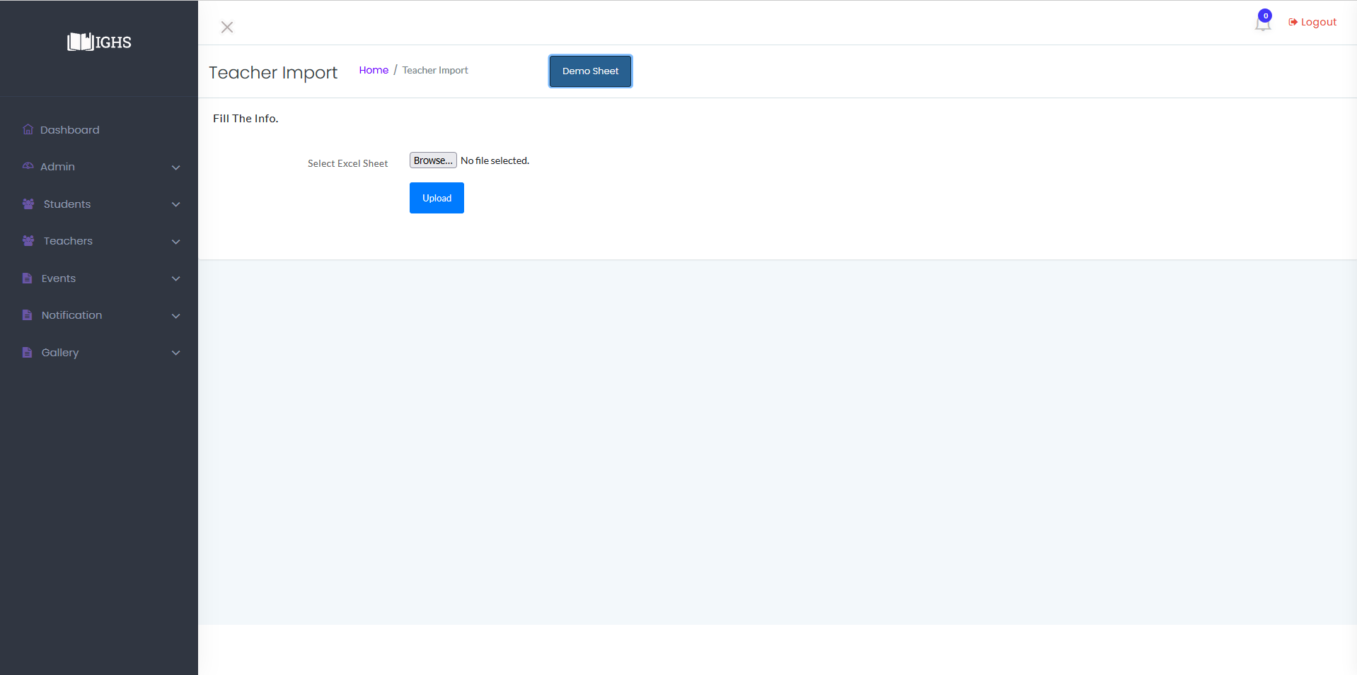

**Image-3.2**

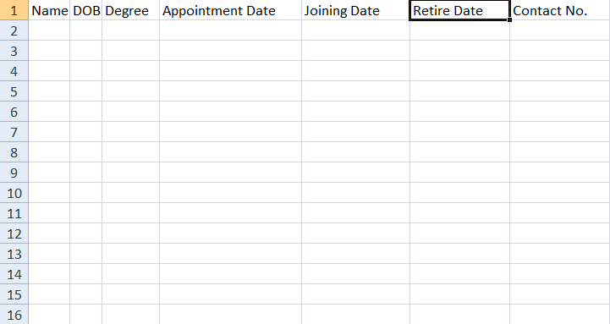

**Image-3.2.1**

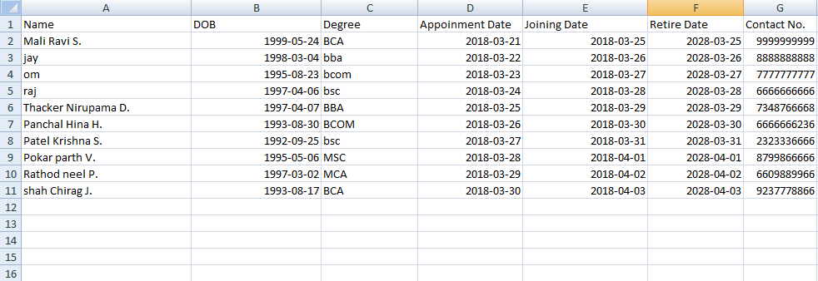

**Image-3.2.2**

**Manage Teacher**

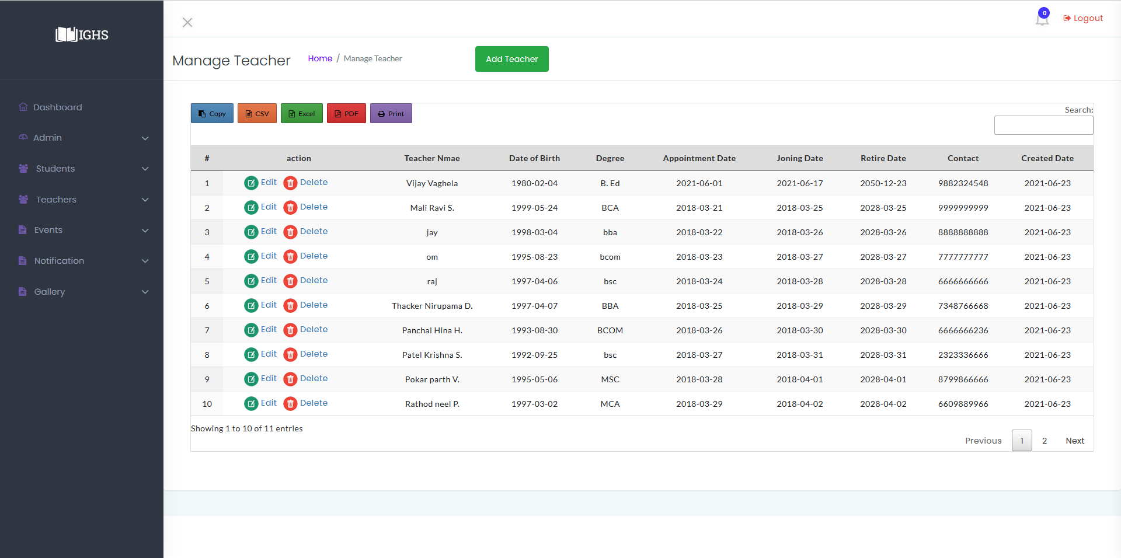

**Image-3.2.3**

**Edit Teacher**

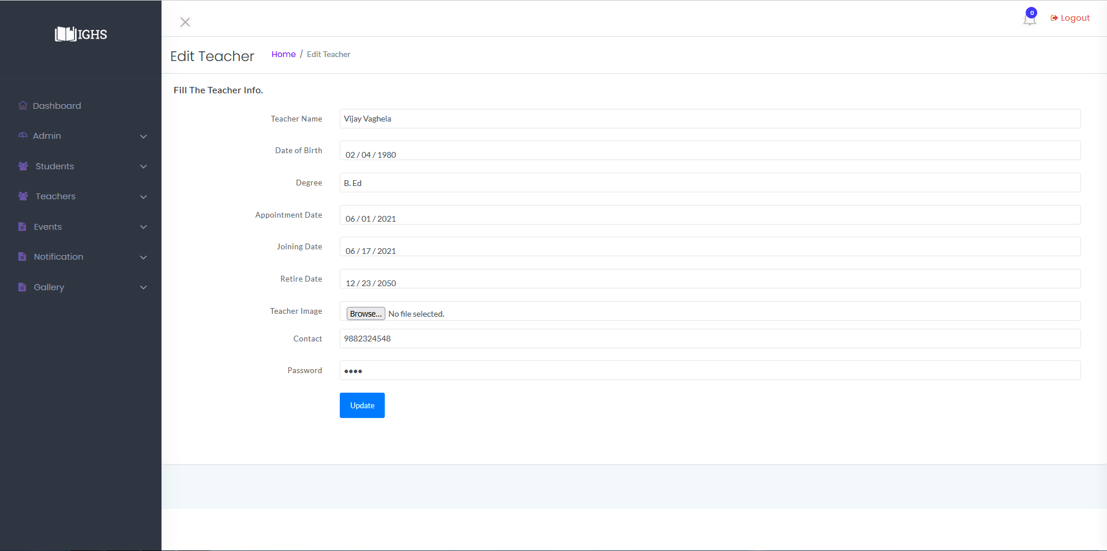

**Image-3.3**

**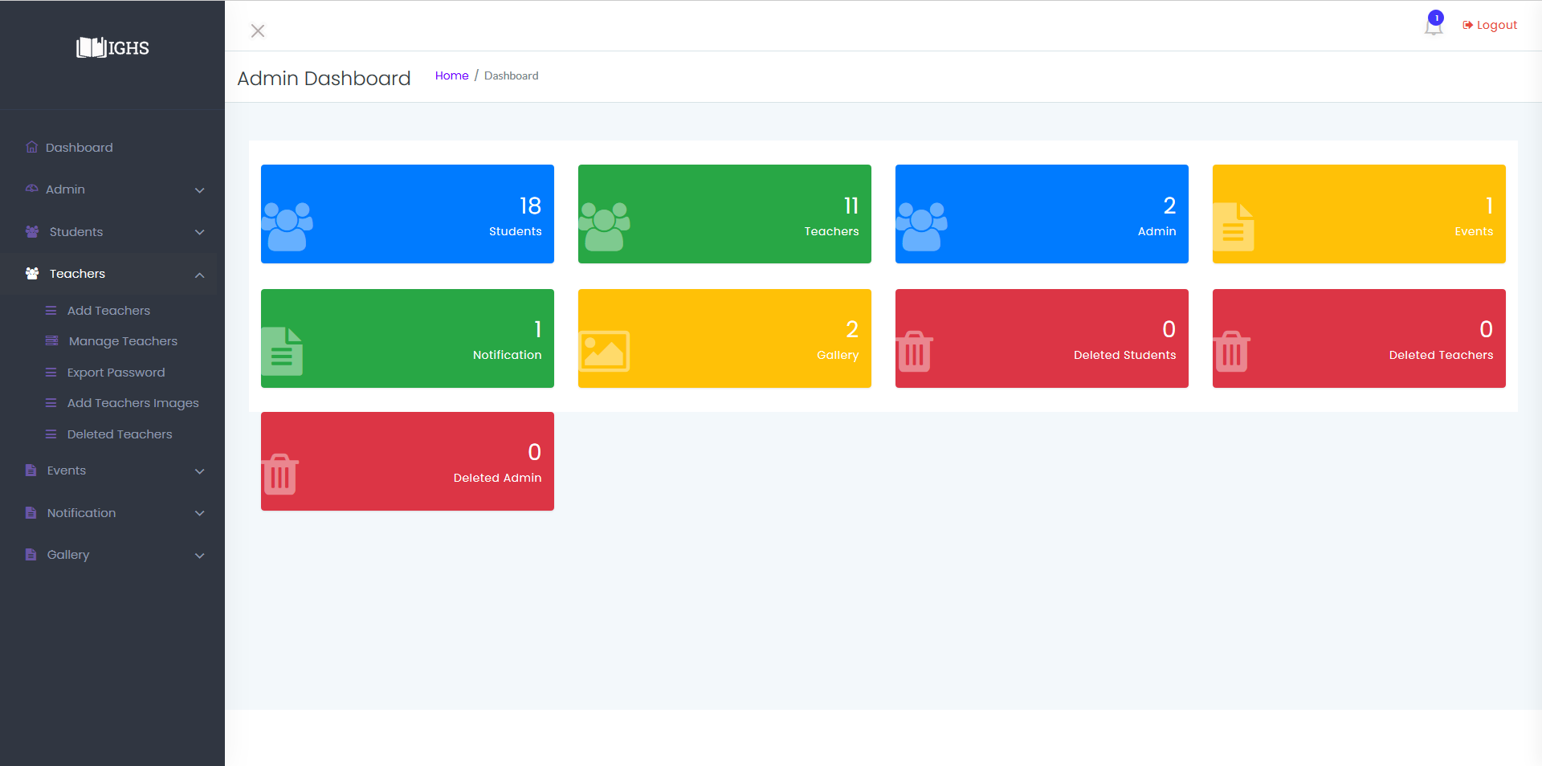  
Image-3.4**

* **NOTE :-**
* **Every process ,**
  + **Add Teacher**
  + **Import Teacher**
  + **Manage Teacher**
  + **Delete Teacher**
  + **Restore Teacher**
  + **Export Teacher Password**
  + **Edit Teacher**

are same as Admin :Manage Student except "Add Teacher Image". In For students admin needs to rename images to Gr. number and for Teachers Admin requires to write Full name of Teacher as Image name .

**Export Teacher Passwords**

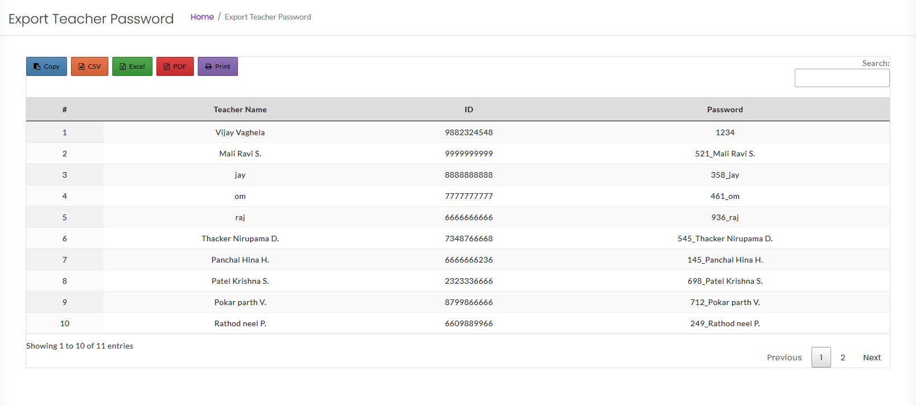

**Image-3.4.1**

**Add Teacher Images**

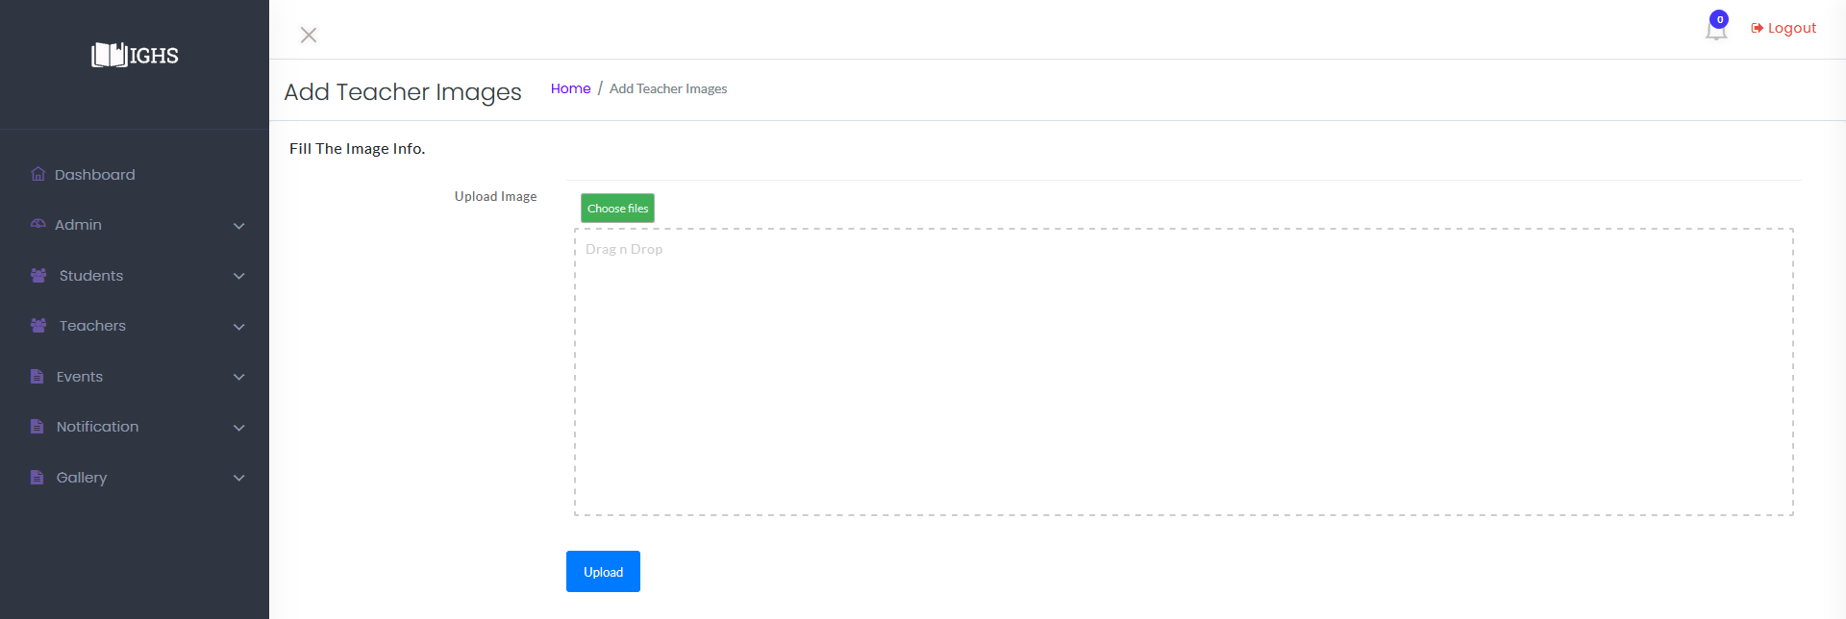

**Image-3.4.2**

**Admin : Manage Admin**

* Features in Manage Admin are as below ,
  + Add admin
  + Manage admin
  + Edit admin
  + Delete admin
  + Restore admin

which are also same as Manage Student and Manage Teacher and its snapshots are as below .

**Manage Admin**

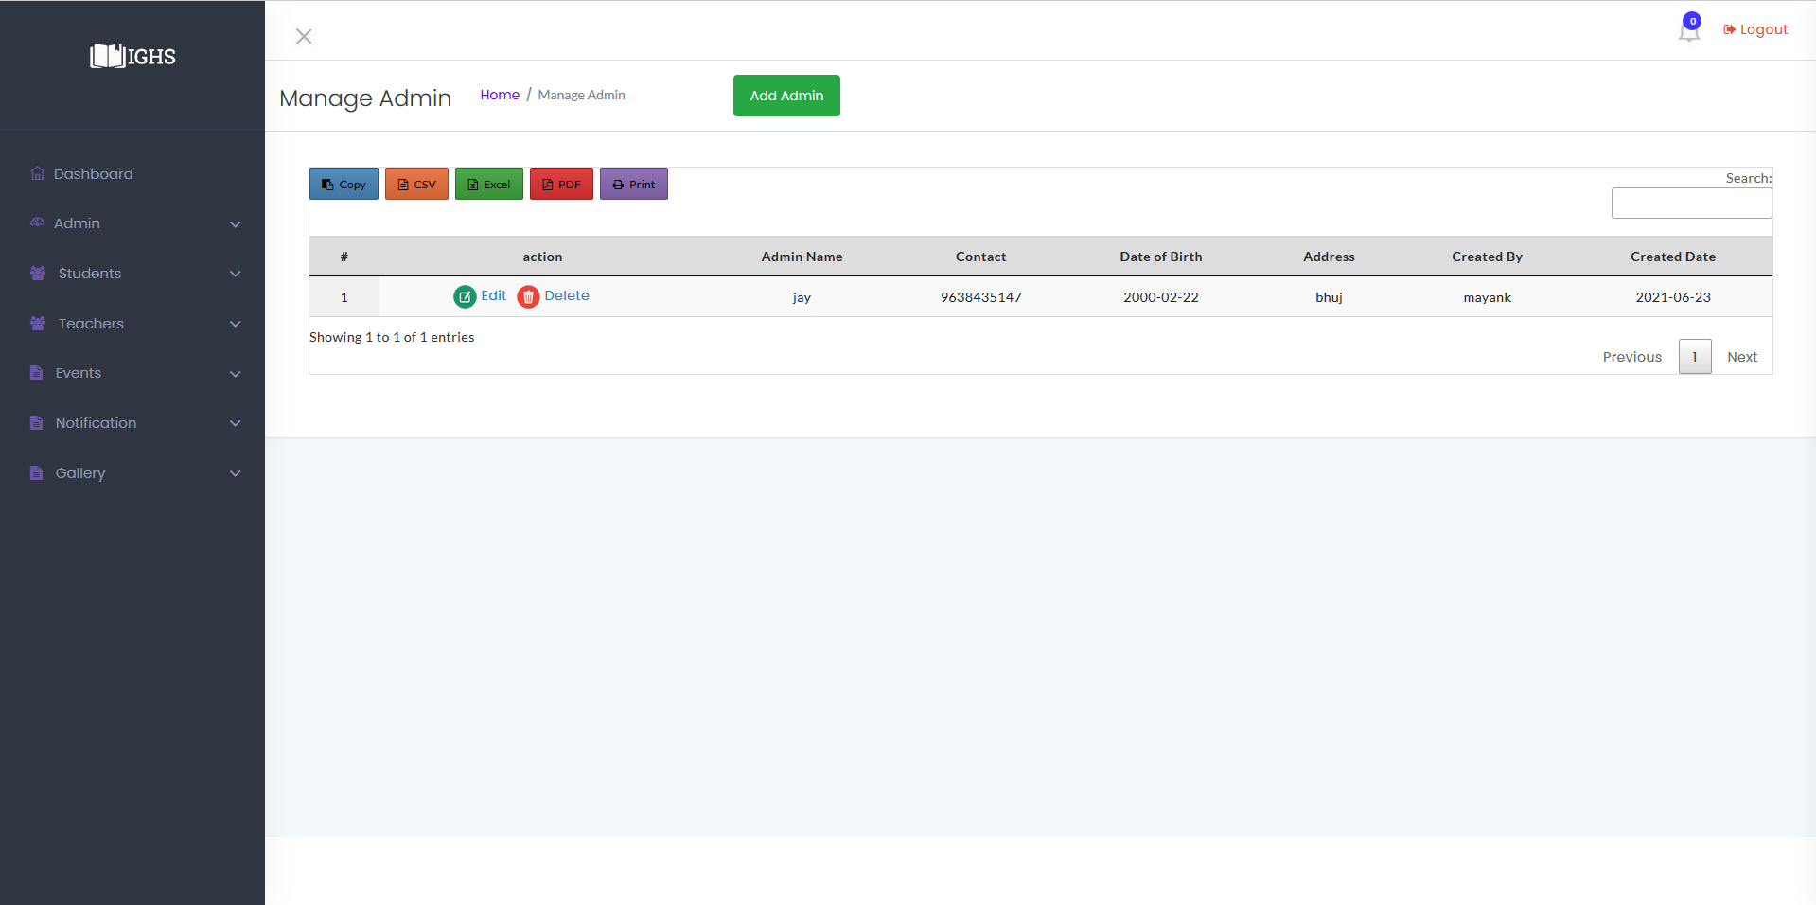

**Image-4**

**Add Admin**

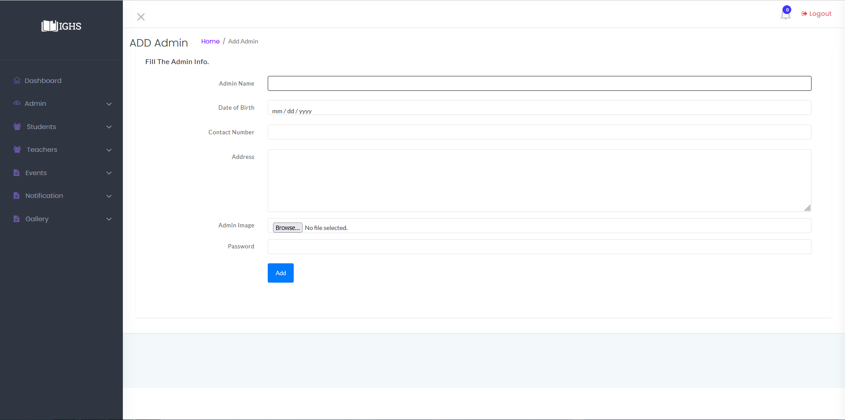

**Image-4.1**

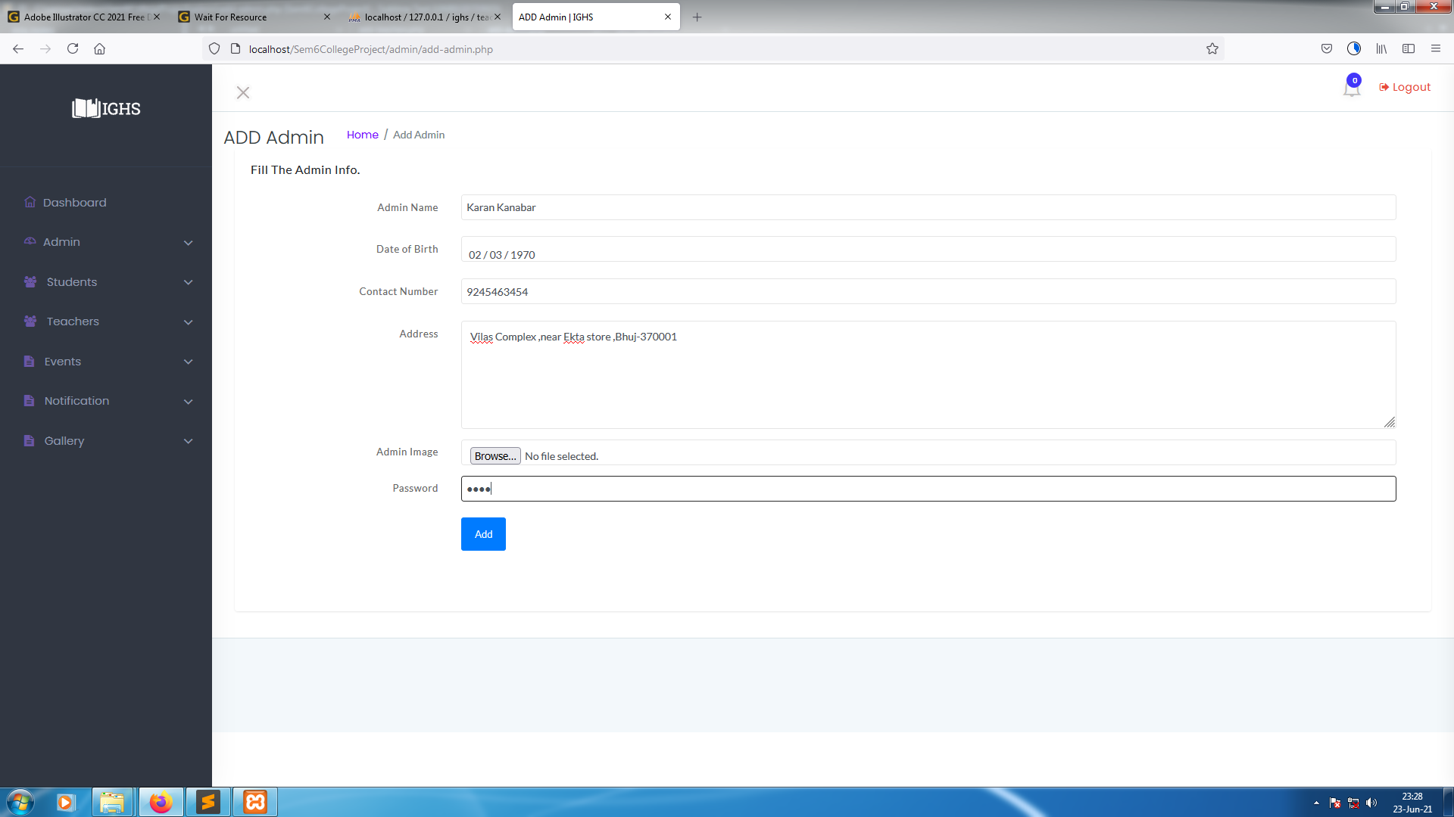

**Image-4.1.1**

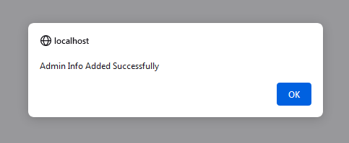

**Image-4.1.2**

**Edit Admin**

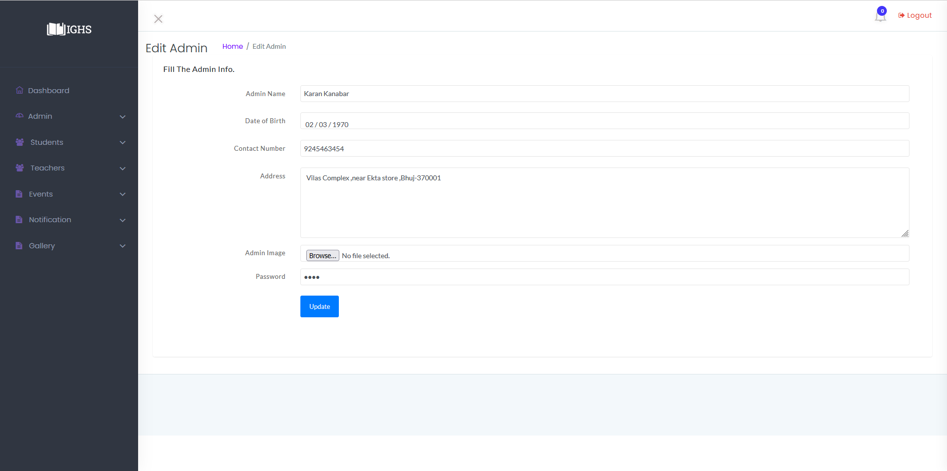

**Image-4.2**

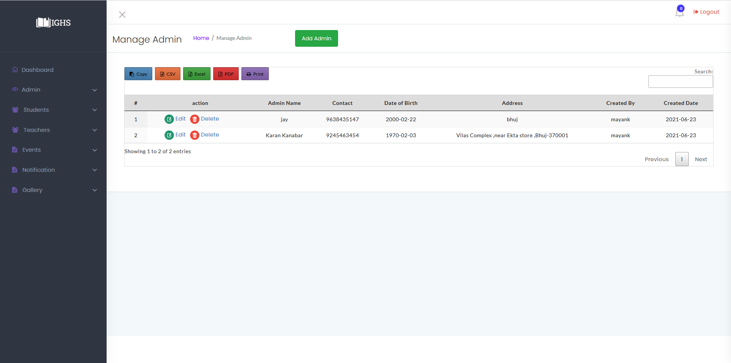

**Image-4.3**

**Admin : Manage Event**

* In manage Event features are as below :-
  + Create Event :- Admin can create new events .
  + Delete Event : - Admin can delete Events.
  + Edit Event :- Admin can edit Existing events.
  + Disable Event :- Keeps the Event in system but nobody can see it.
  + Enable Event :- Enables previously disabled events, so everyone can see it.

Its snapshots are as below .

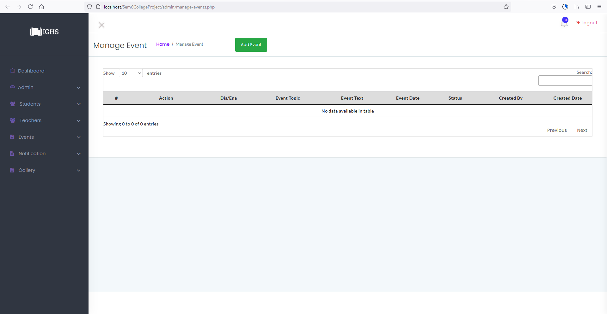

**Image-5**

**Add Event**

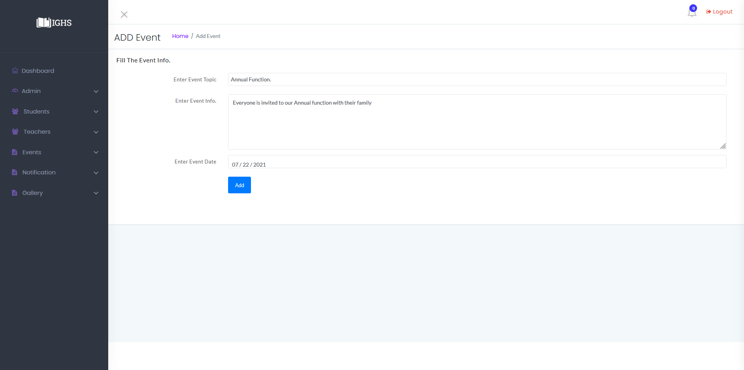

**Image-5.1**

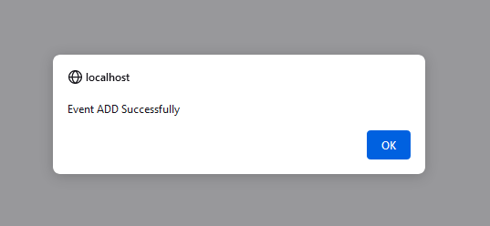

**Image-5.1.1**

**Disable/Enable Events**

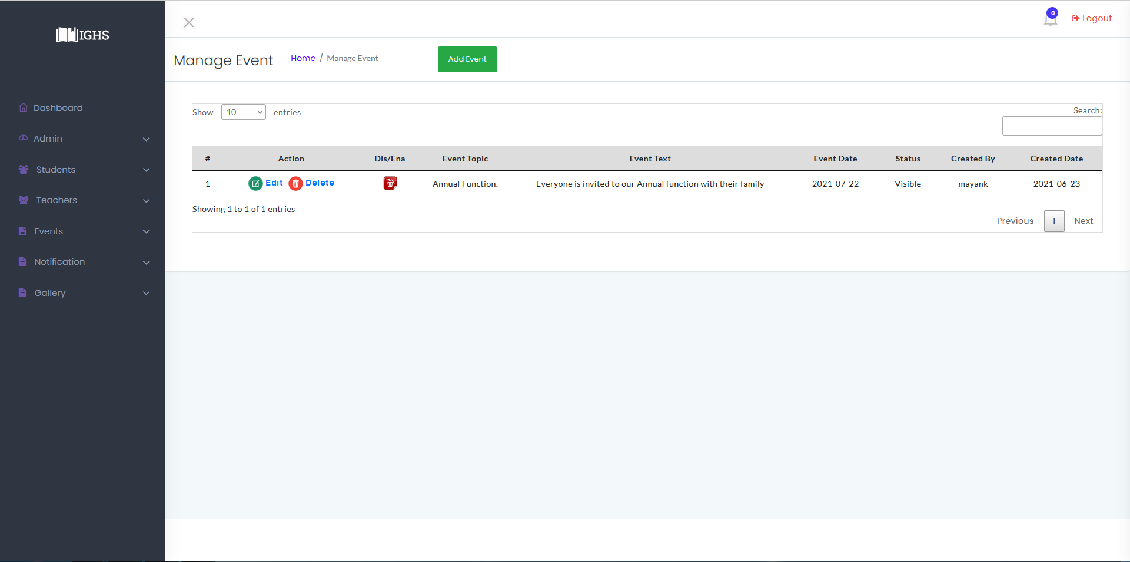

**Image-5.2**

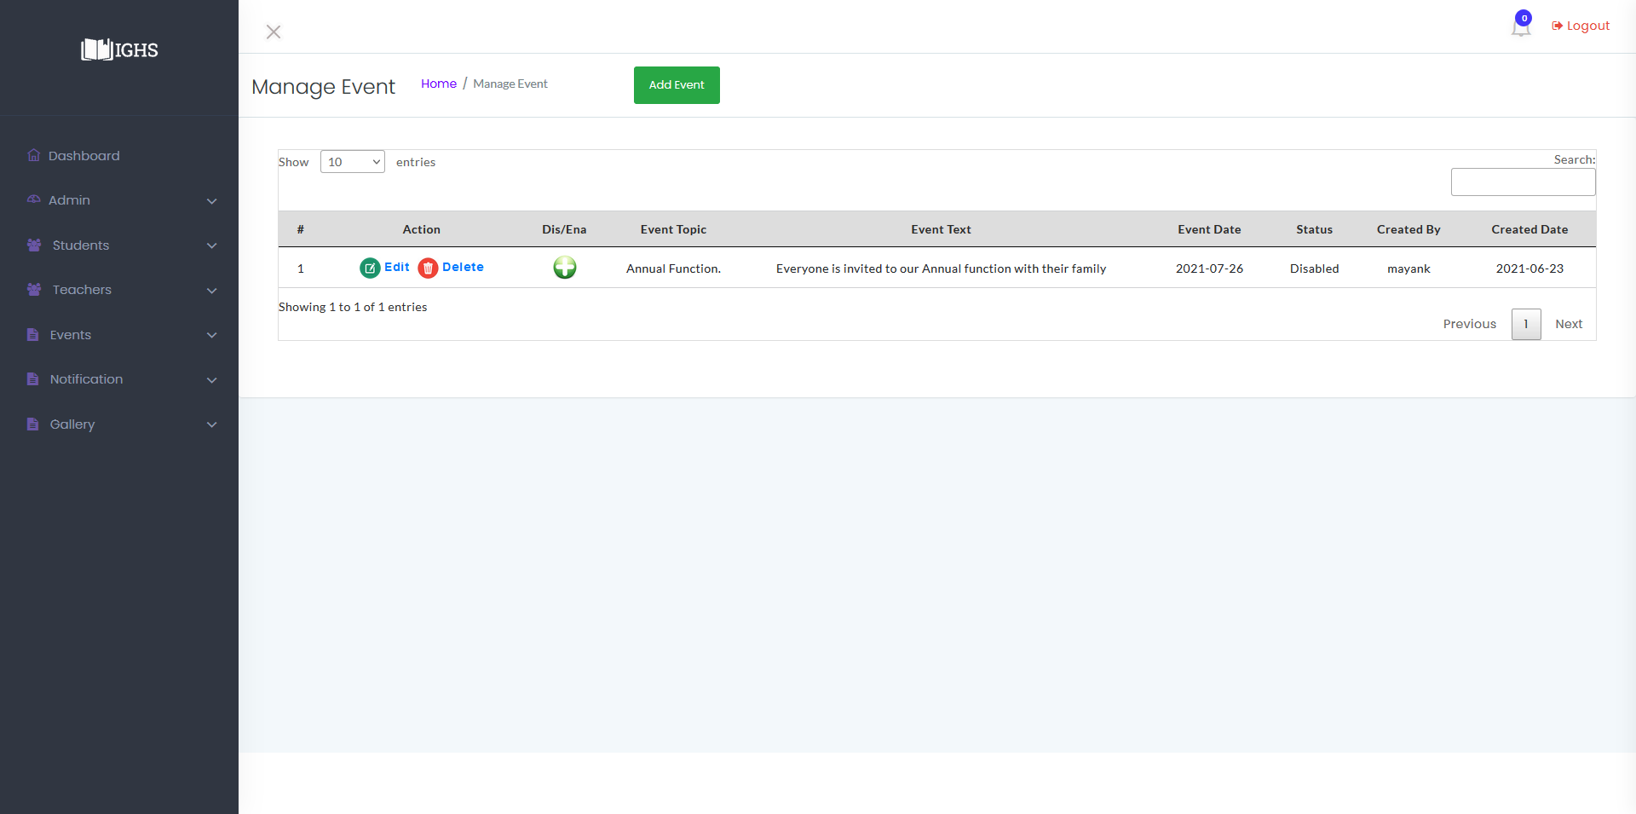

**Image-5.2.1**

**Edit Event**

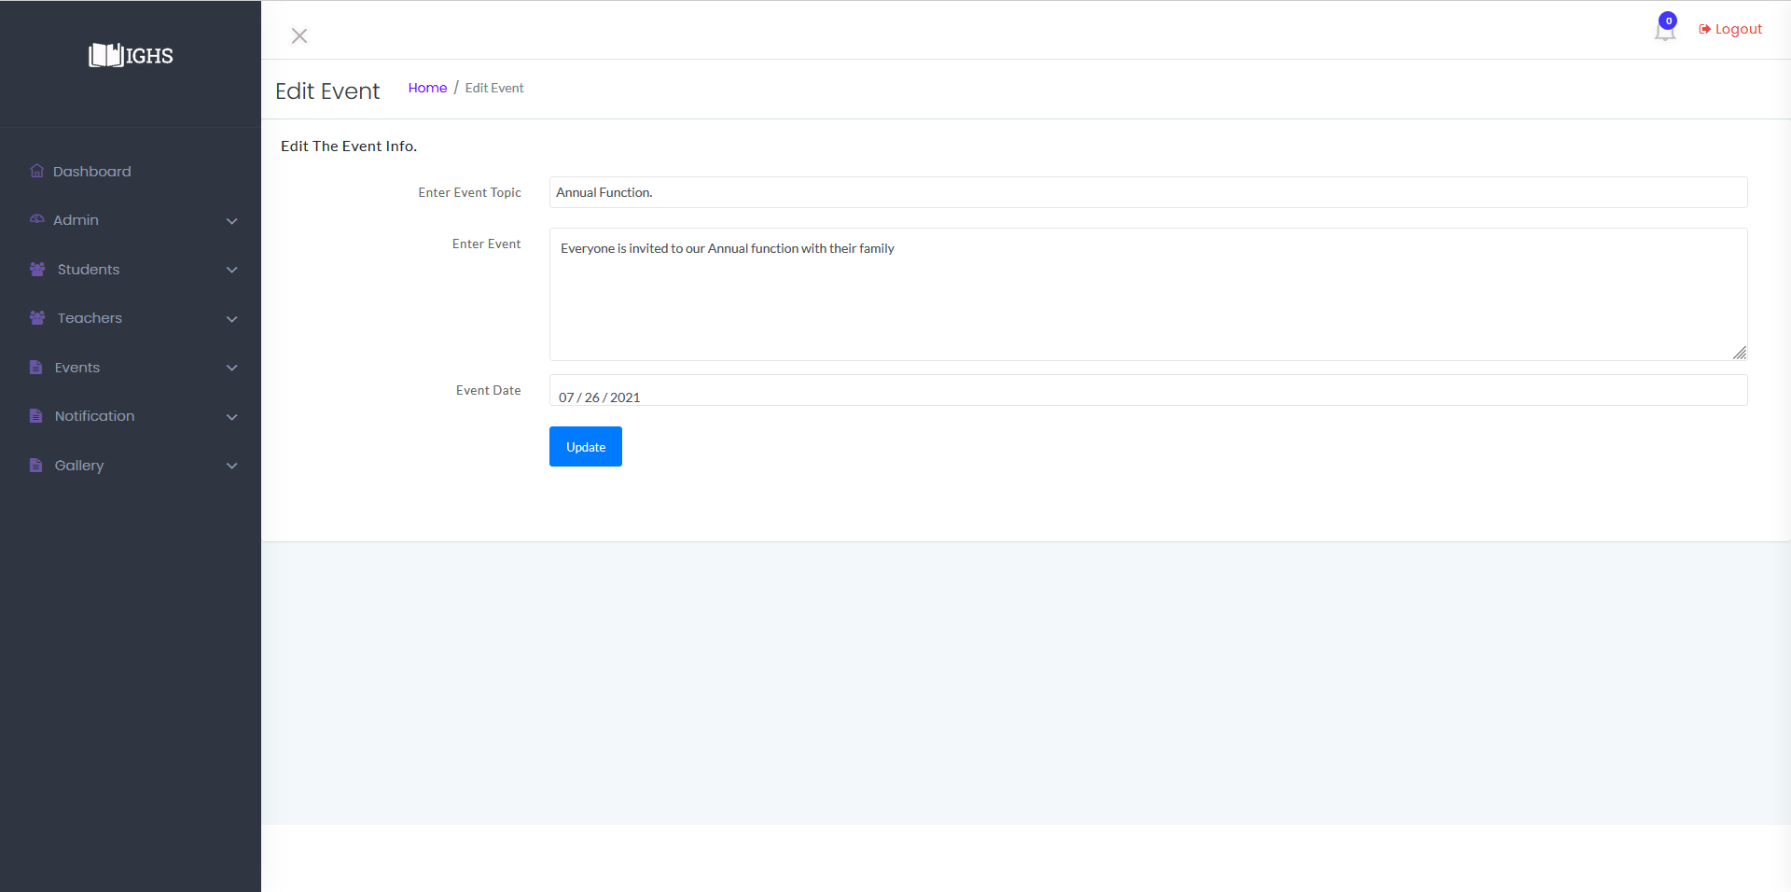

**Image-5.3**

**Admin : Manage Notification**

* In manage Notification features are as below :
  + Add Notification
  + Manage Notification
  + Edit Notification
  + Delete Notification

and its snapshots are as below :-

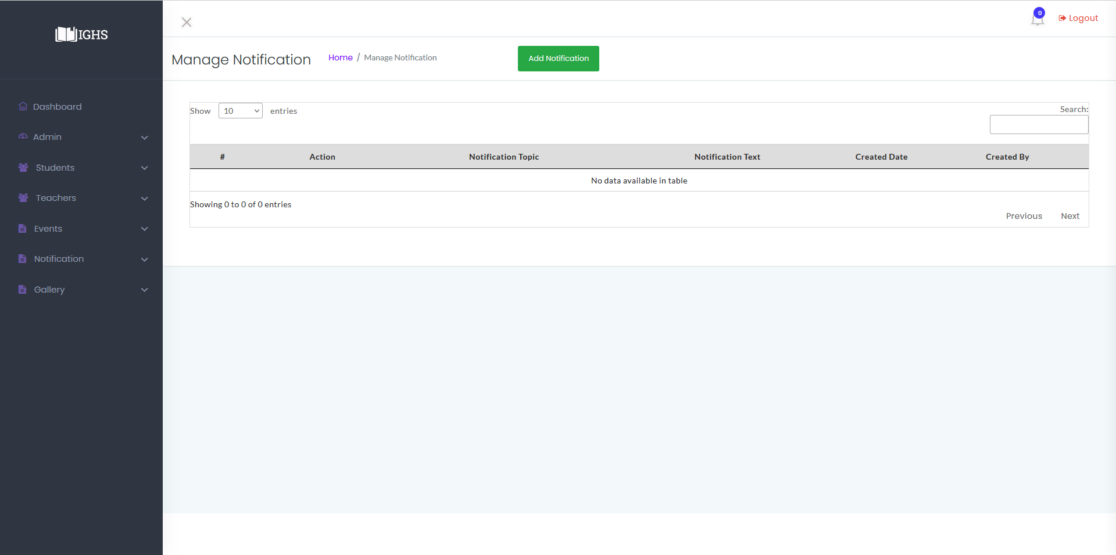

**Image-6**

**Add Notification**

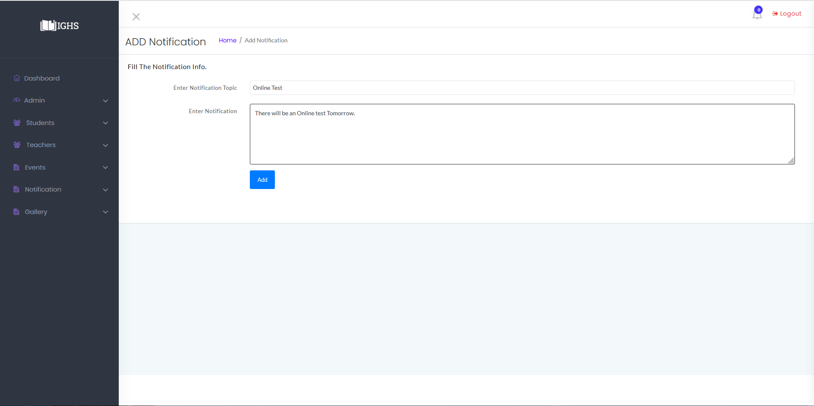

**Image-6.1**

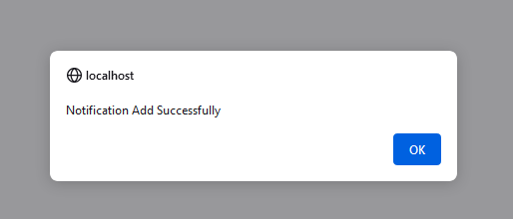

**Image-6.1.1**

**Manage Notification**

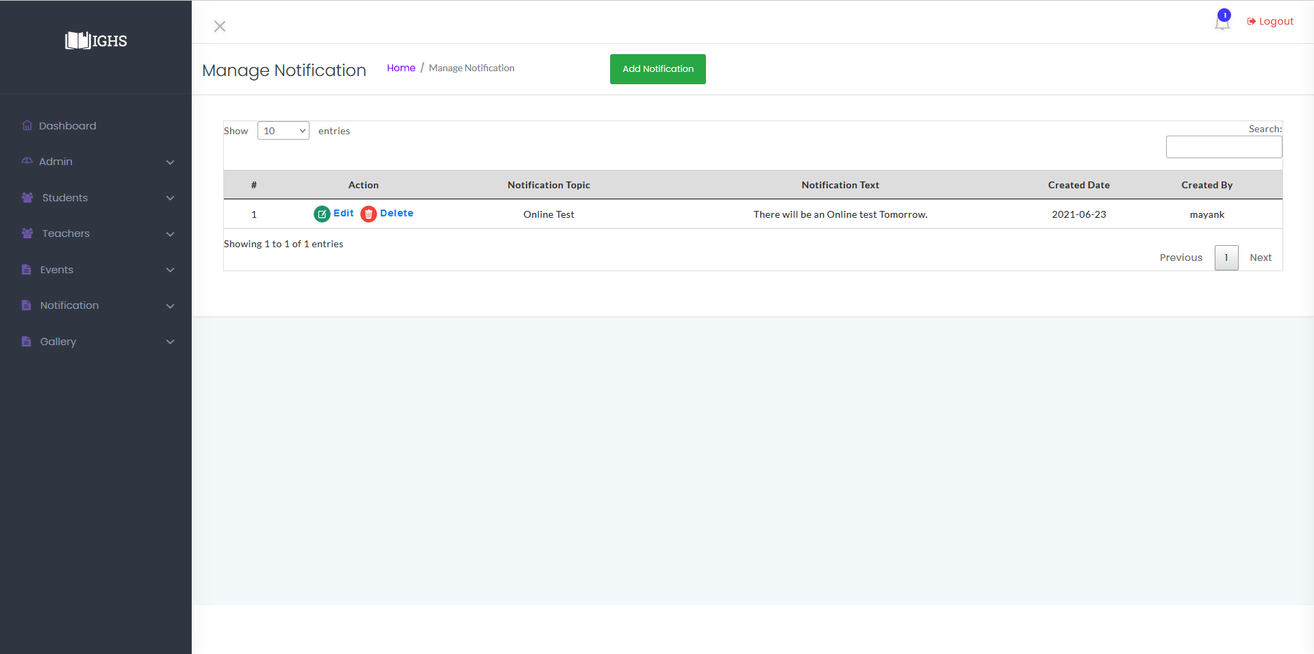

**Image-6.1.2**

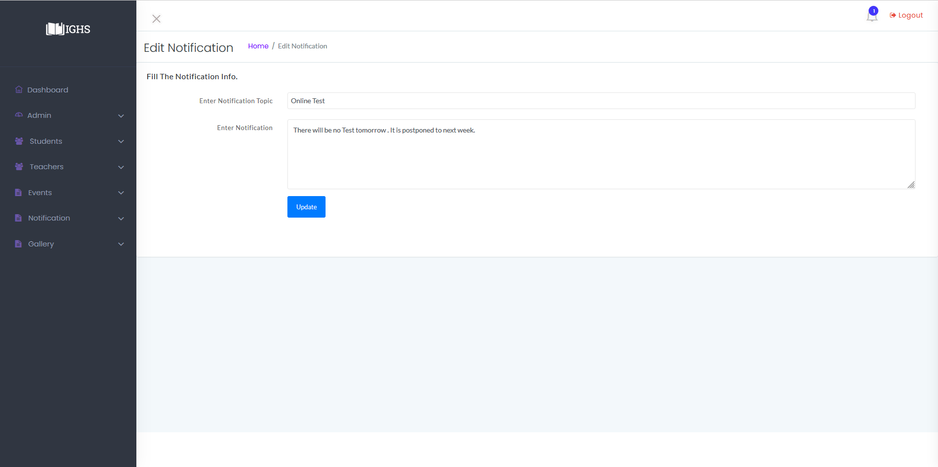

**Image-6.2**

**Admin : Manage Gallery**

* In Manage Gallery features are as below :
  + Add Images
  + Delete Image

and its snapshots are as below :-

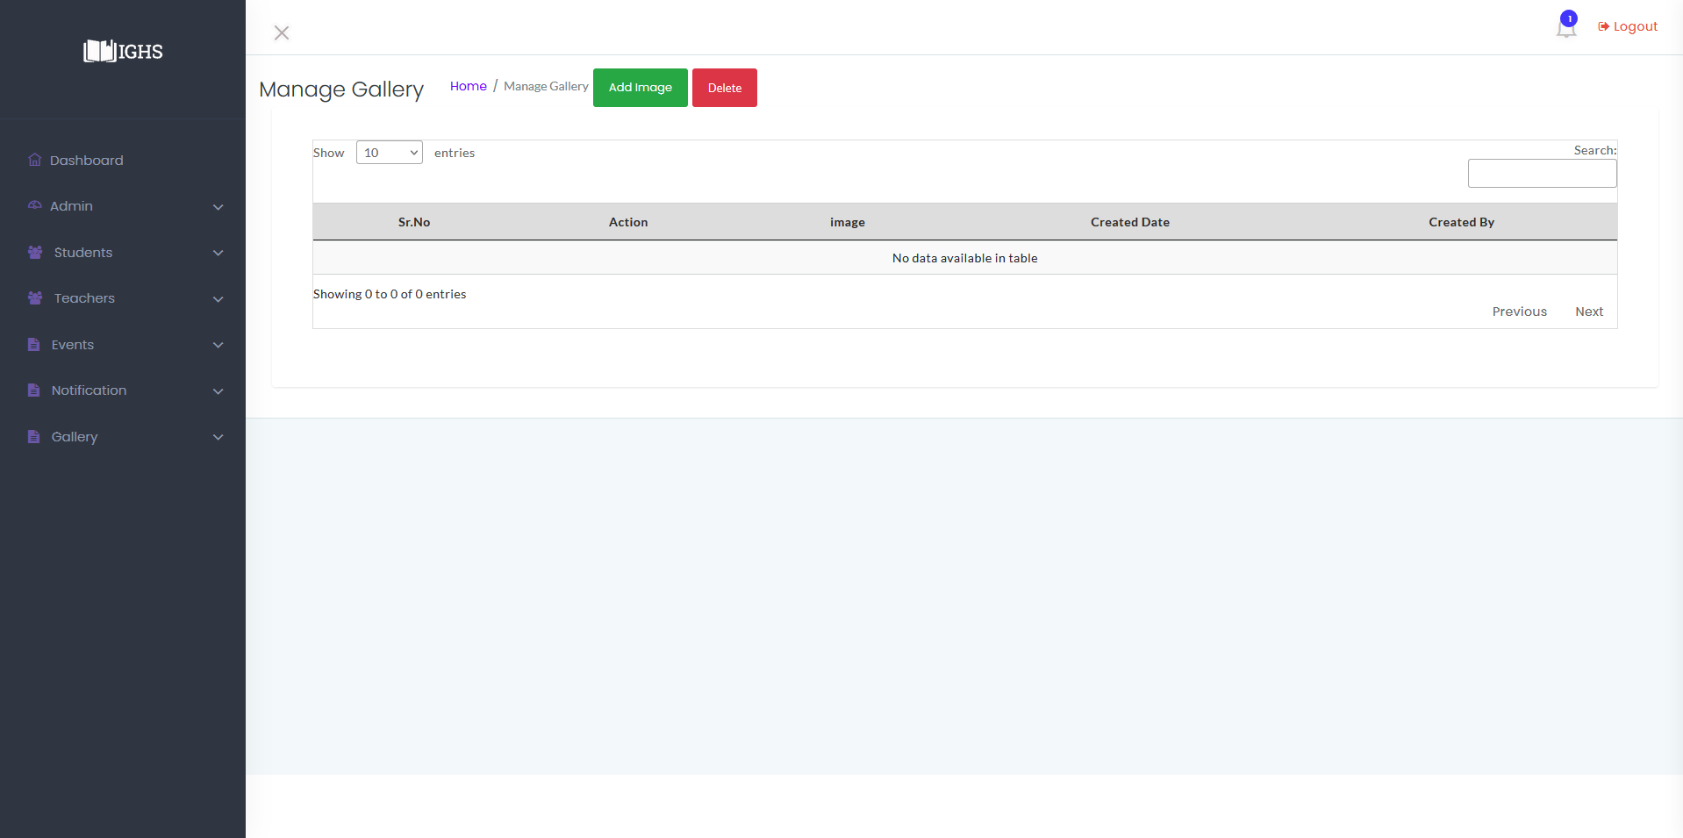

**Image-7**

**Add Images**

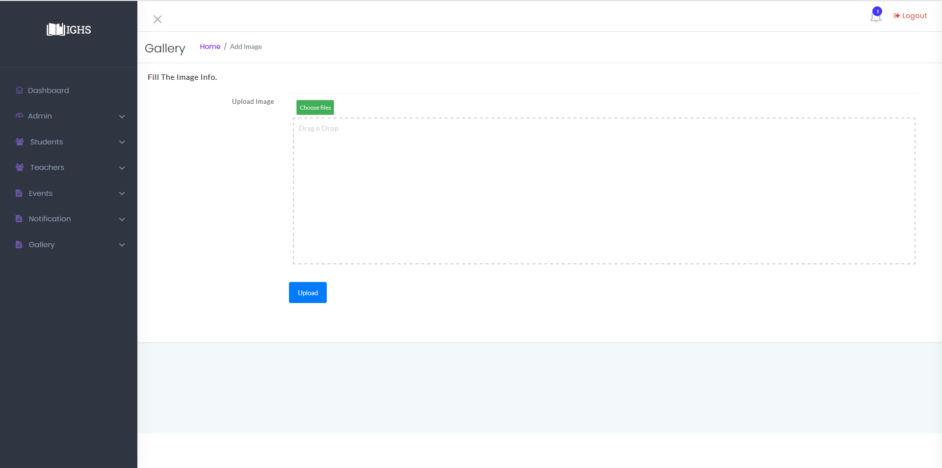

**Image-7.1**

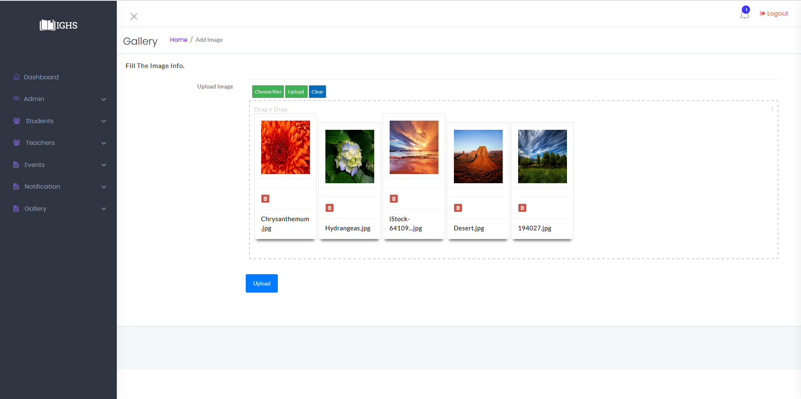**Image-7.1.1**

**Manage Gallery**

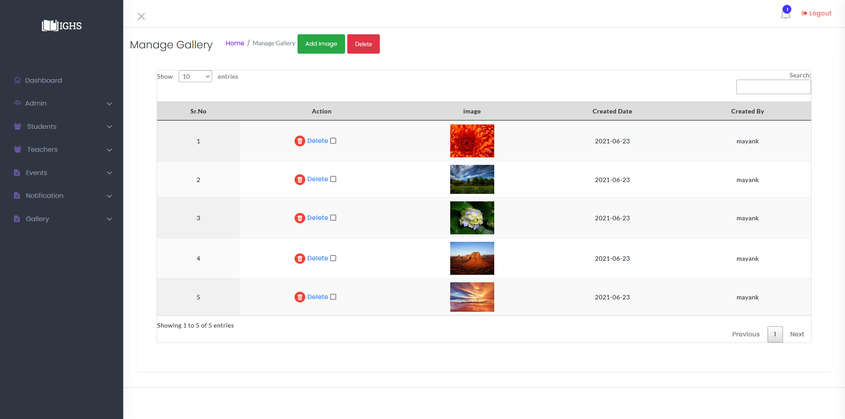

**Image-7.1.1**

**Delete Images**

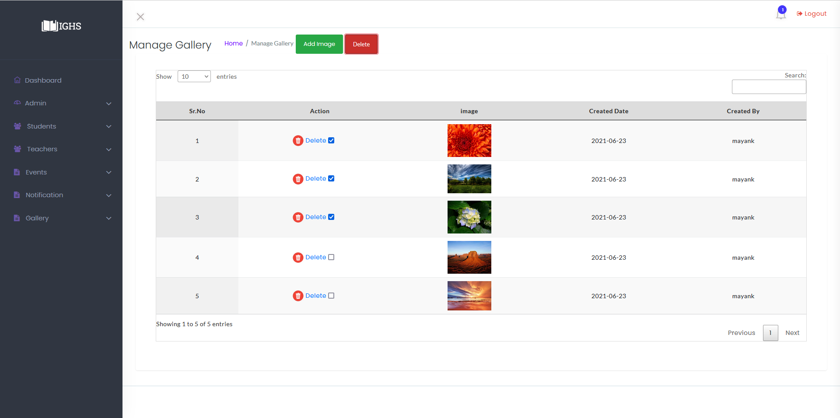**Image-7.2**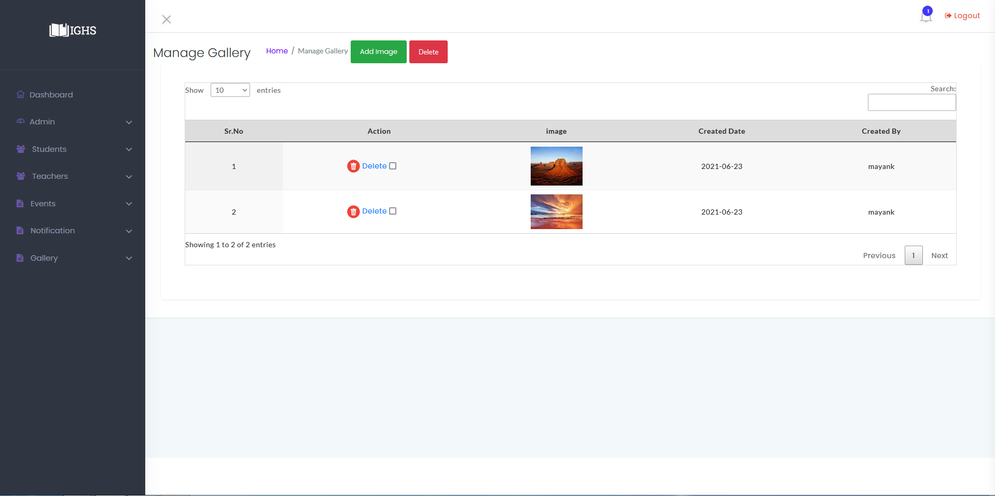

**Image-7.2.1**

**Admin : Profile**

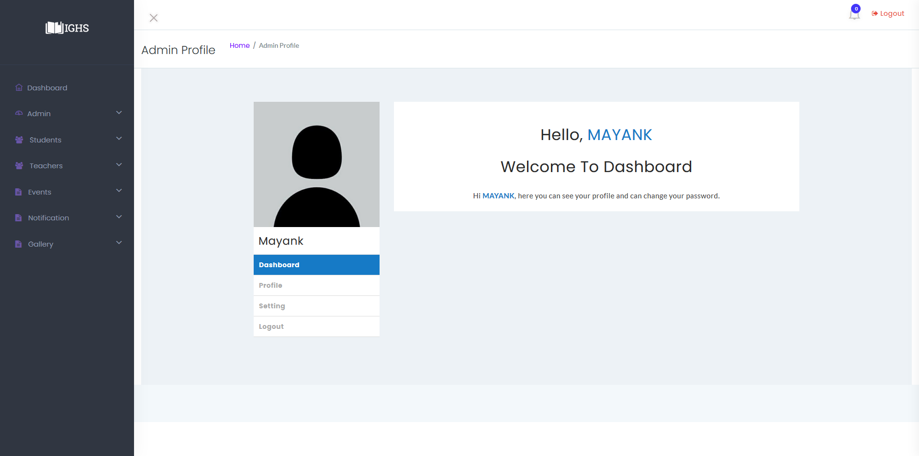

**Image-8**

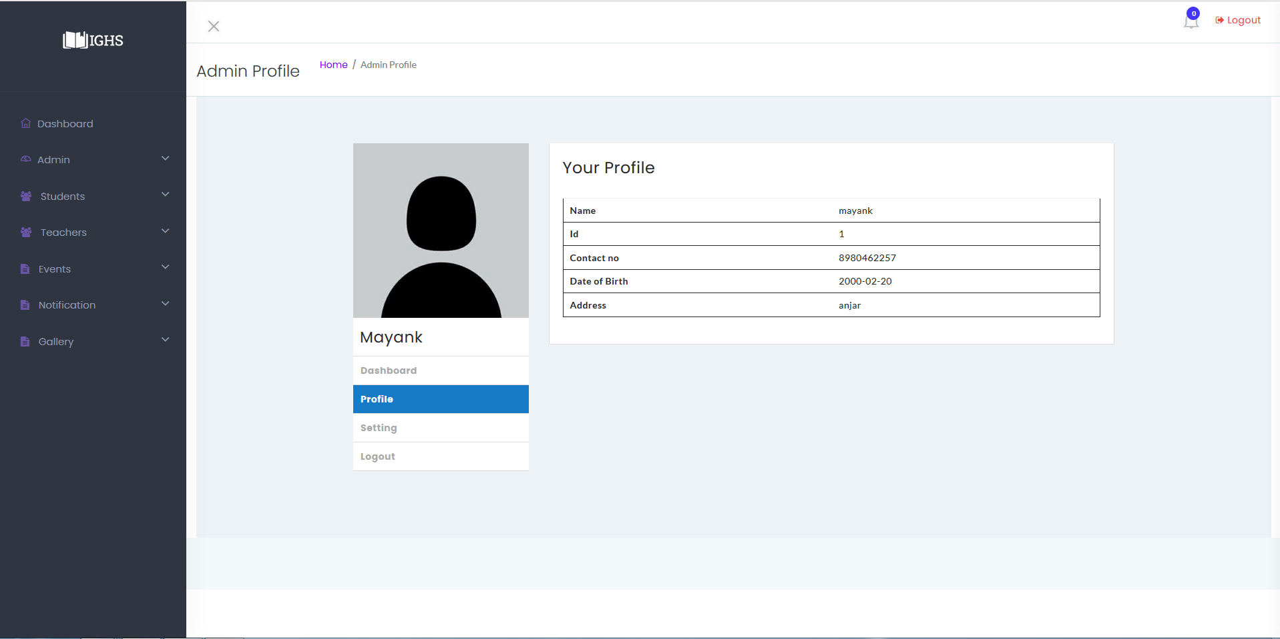**Image-8.1**

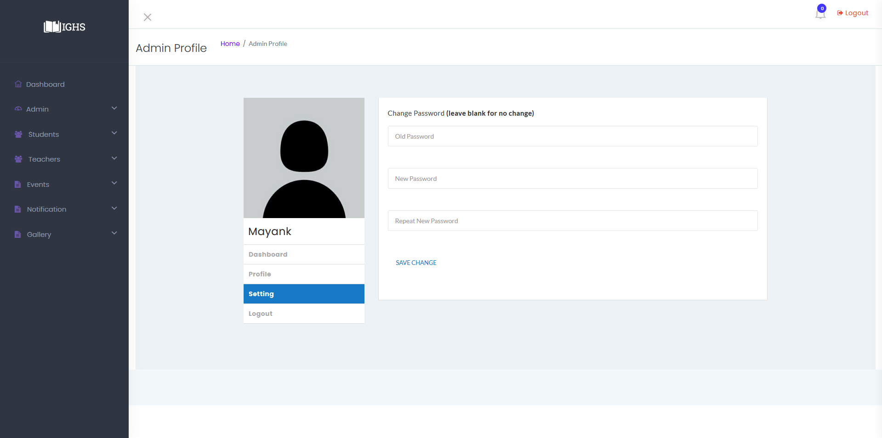

**Image-8.2**

**Teacher Panel**

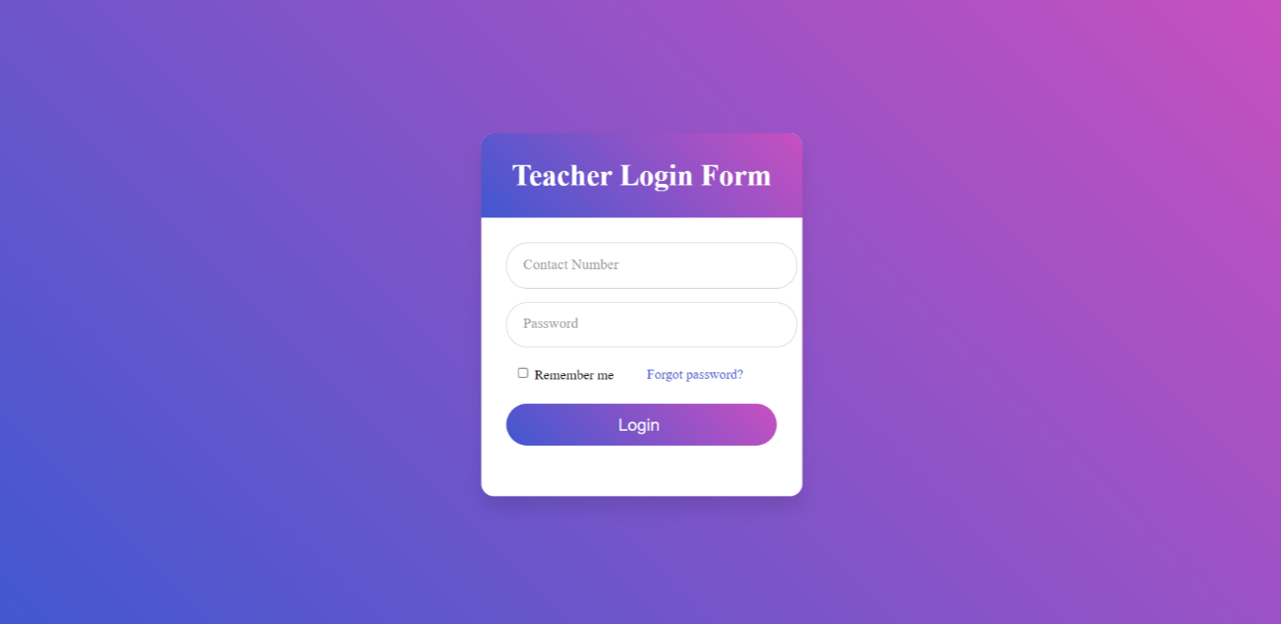

**Image-9**

**Teacher :First Time Login**

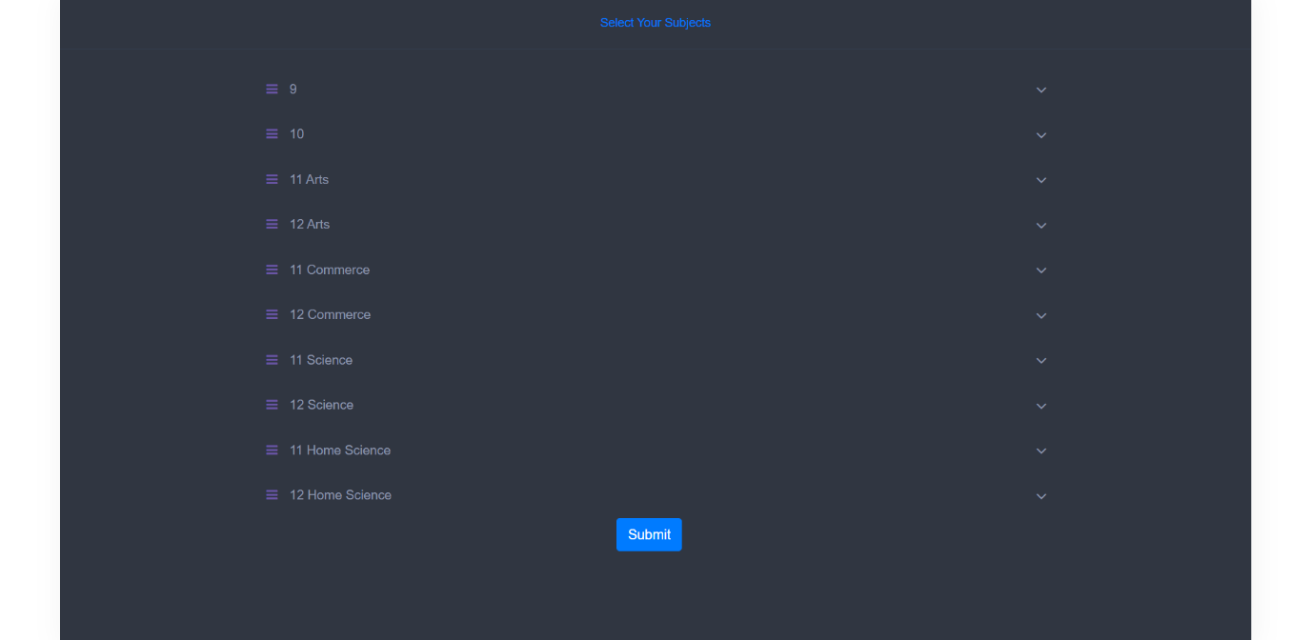

**Image-9.1**

* When teacher logins first time this page will be displayed in order to select which subject teacher takes in every class.

**Teacher : Dashboard**

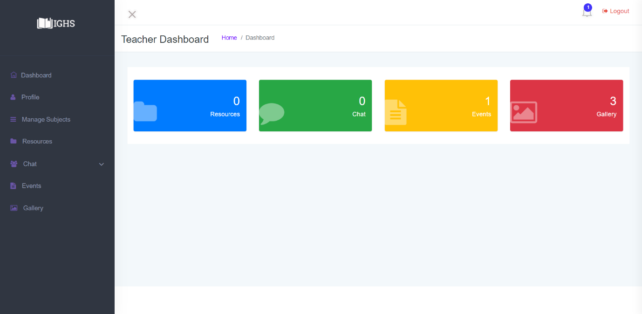

**Image-9.2**

* In dashboard teachers can access their features, teachers features are as listed below :
  + Upload Resources : Teaqcher can upload different files.
  + Delete Resources : Teacher can delete uploaded files.
  + Download Resources : Teacher can download uploaded files.
  + Reply to Students Message : Teacher can message students.
  + Delete Conversation : Teacher can delete conversation for their side only.
  + Checkout Events : Teacher can see Events.
  + Checkout Gallery images : Teacher can see Gallery Images.
  + Reselect subjects : Teacher can reselect their own subjects .

and its snapshots are as below :-

**Teacher : Profile**

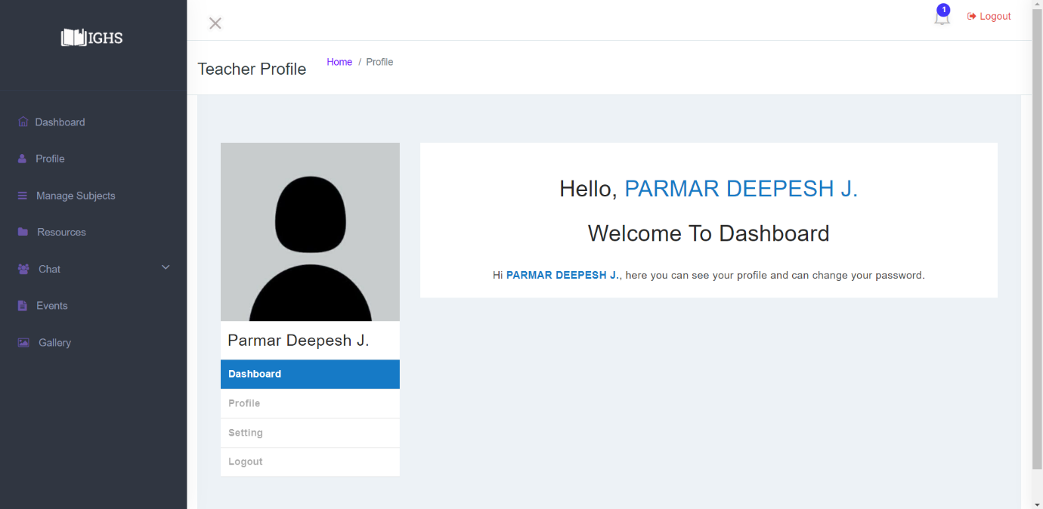

**Image-9.3**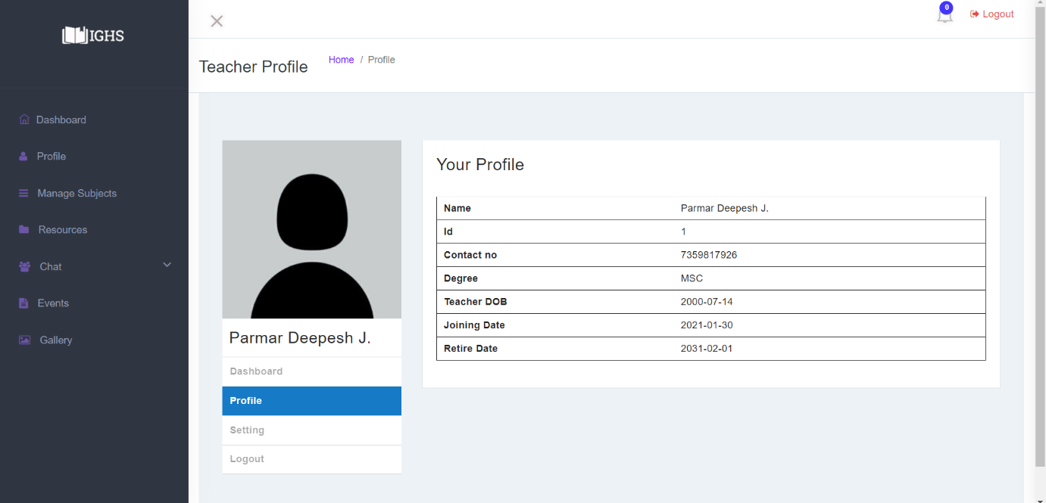

**Image-9.3.1**

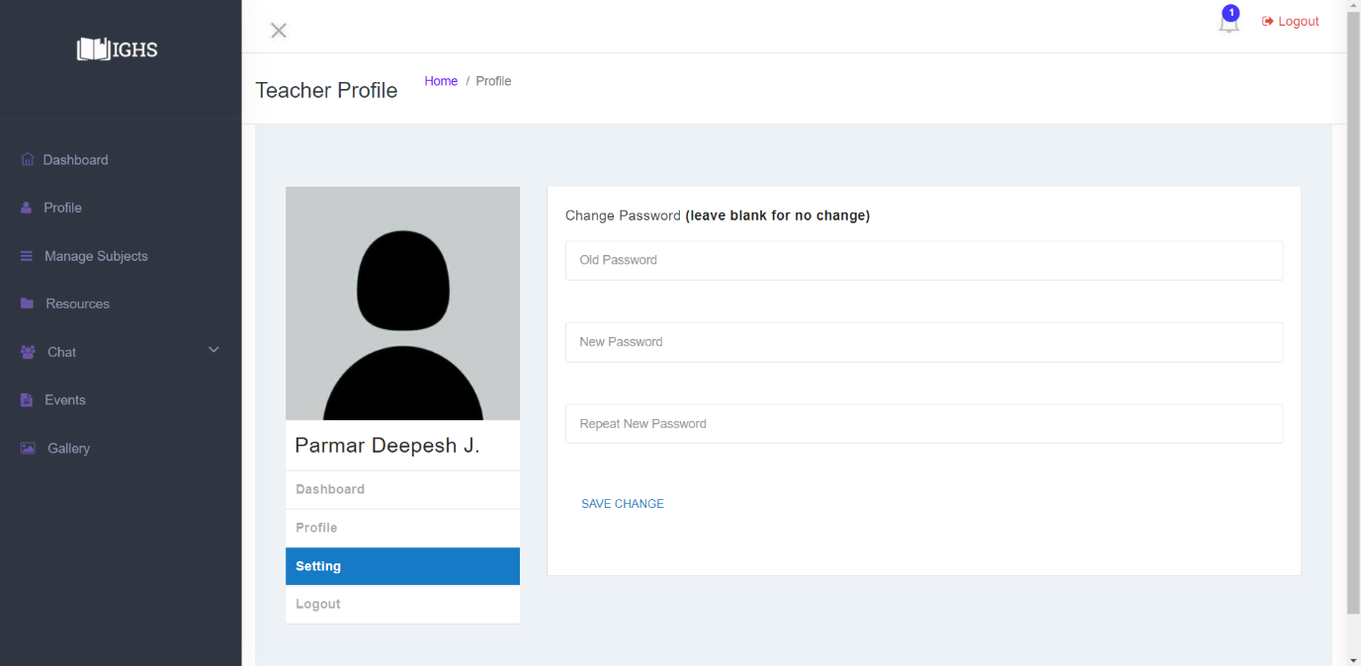

**Image-9.3.2**

**Teacher: Gallery**

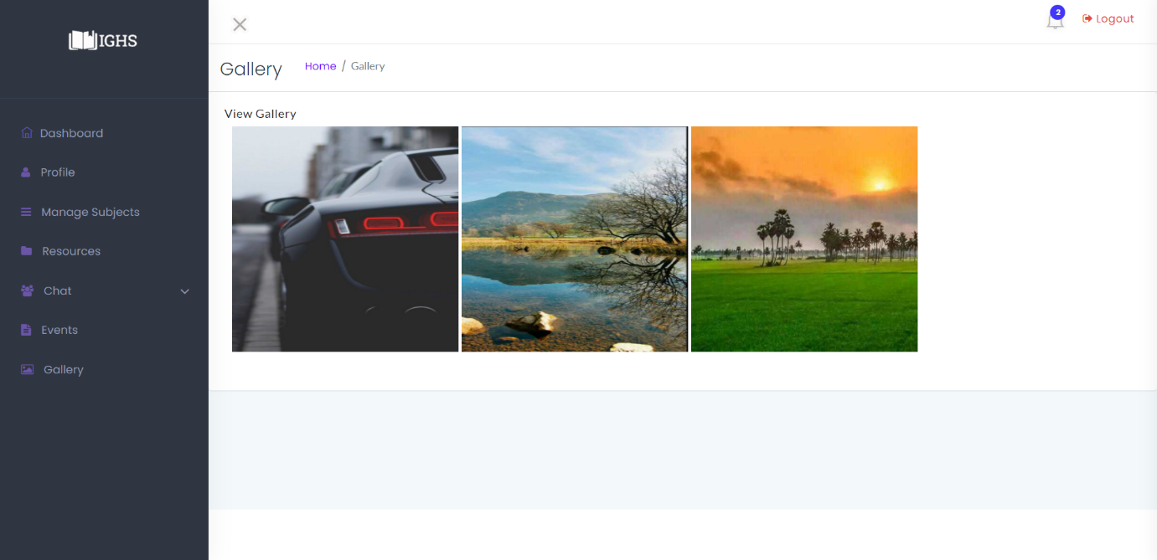

**Image-9.4**

**Teacher : Events**

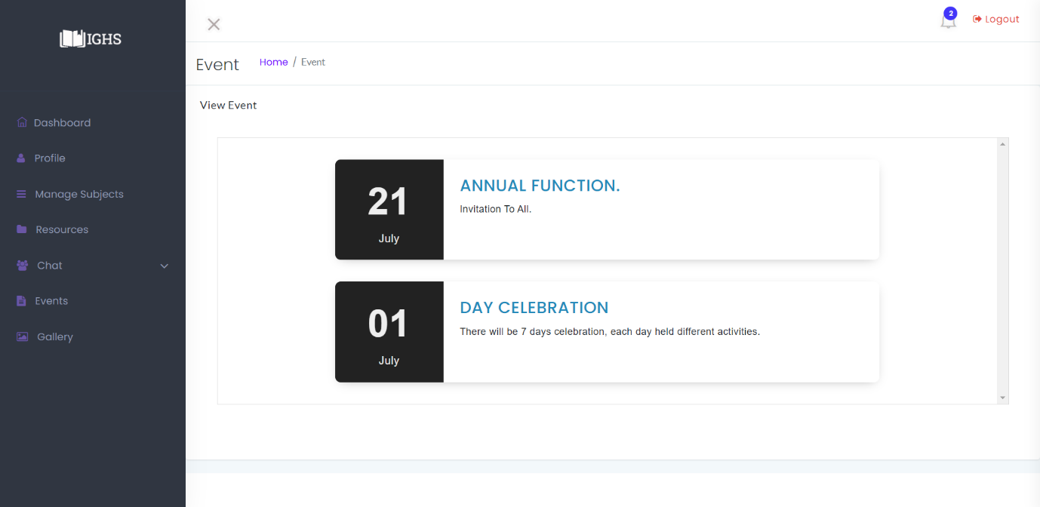

**Image-9.5**

**Teacher : Notification**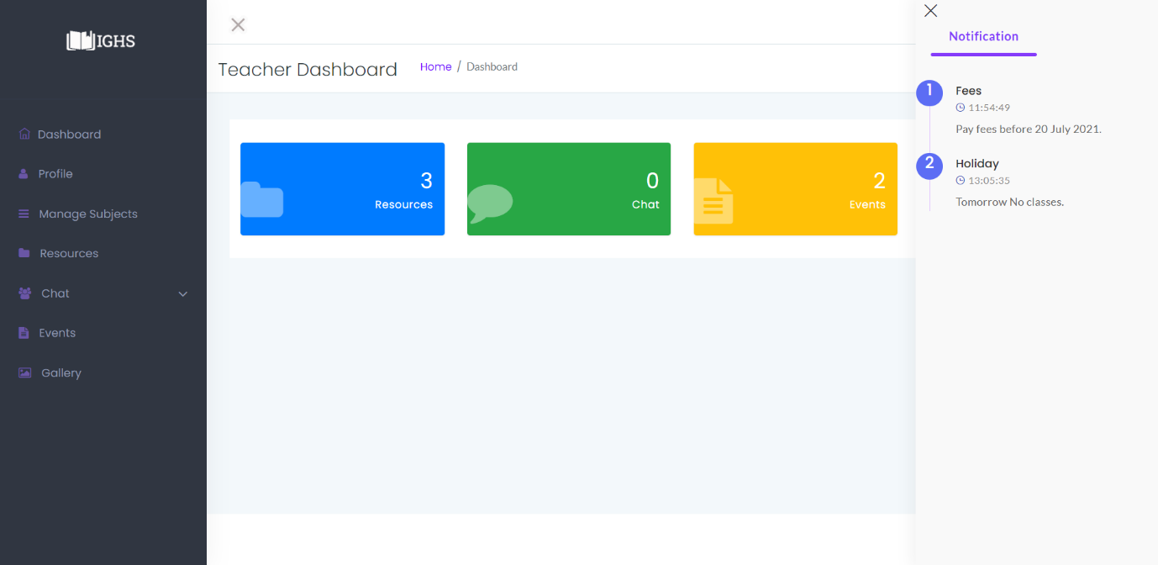

**Image-9.6**

**Teacher : Resources**

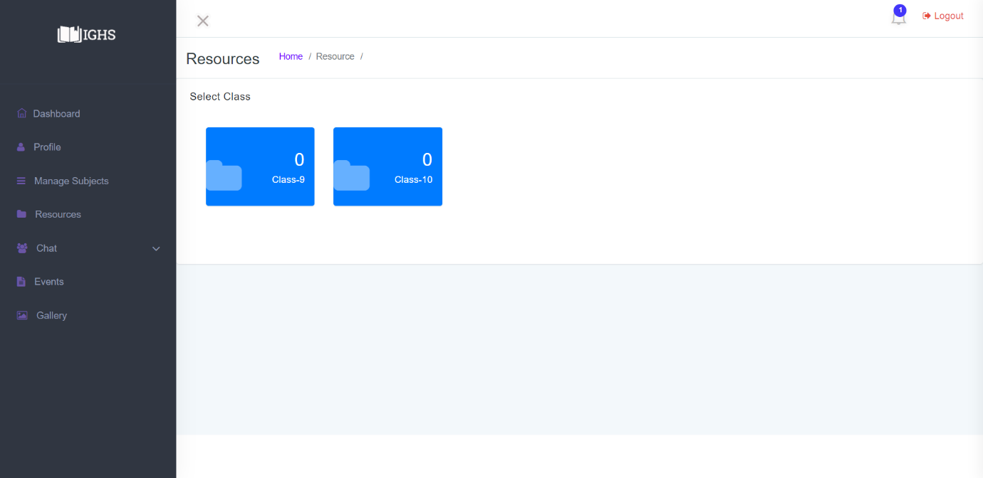

**Image-9.7**

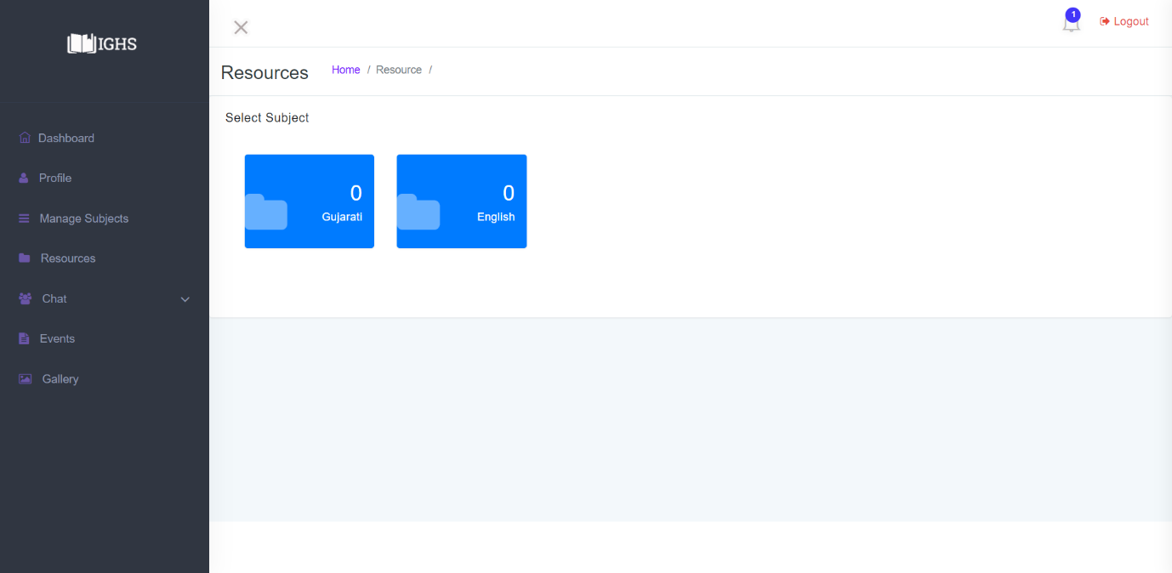

**Image-9.7.1**

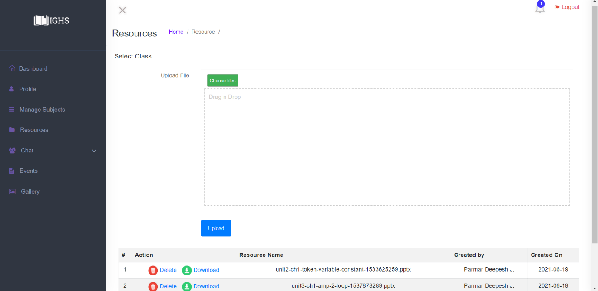

**Image-9.7.2**

**Teacher : Select Subjects**

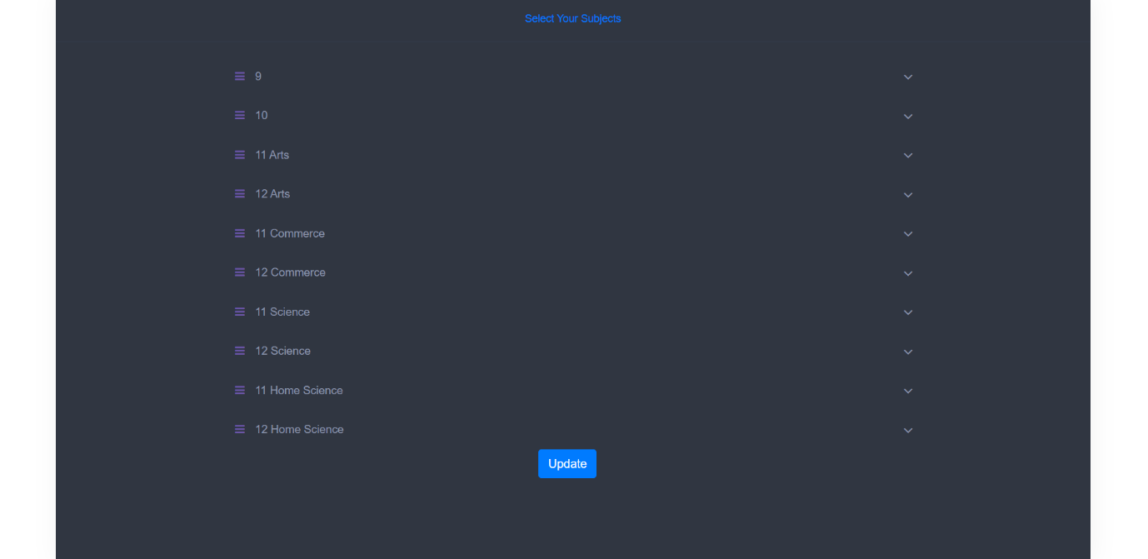

**Image-9.8**

**Teacher :Chat**

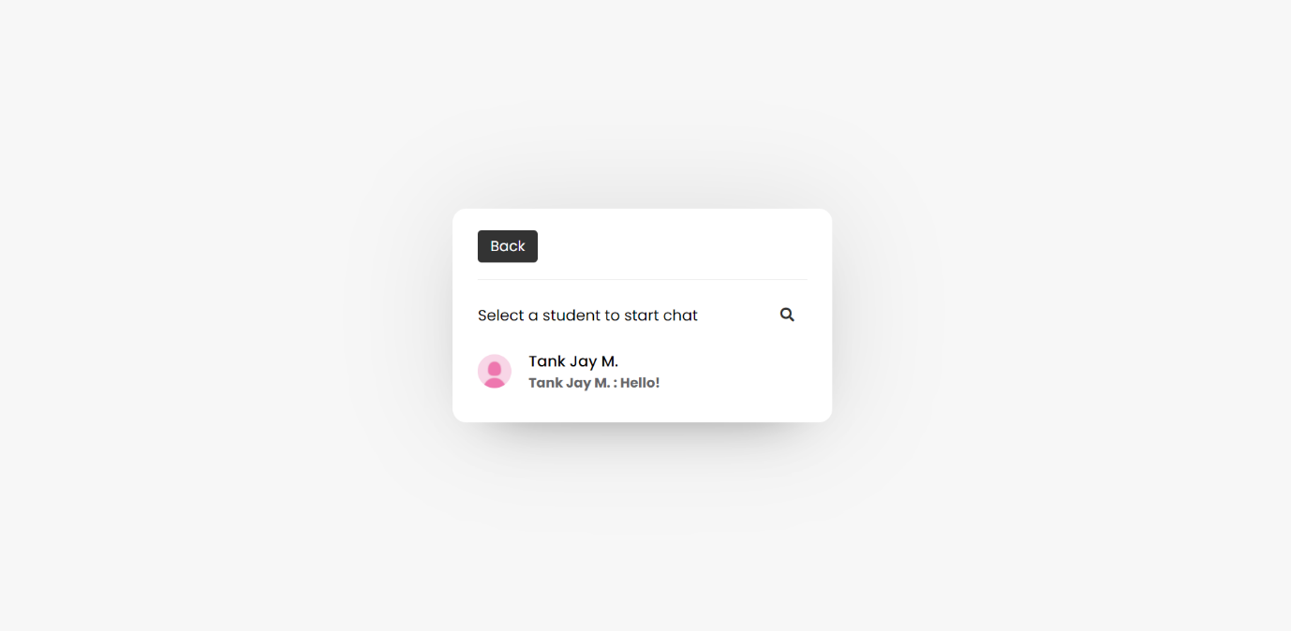

**Image-9.9**

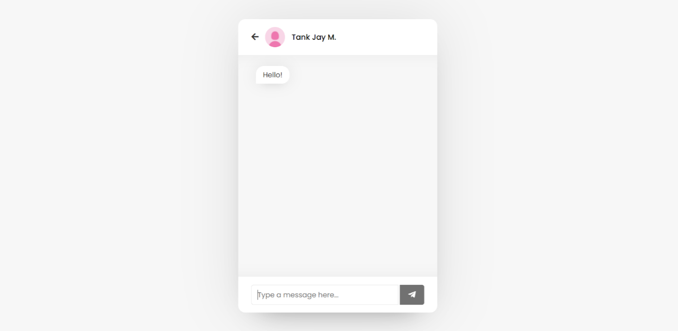

**Image-9.9.1**

**Teacher : Manage Conversations**

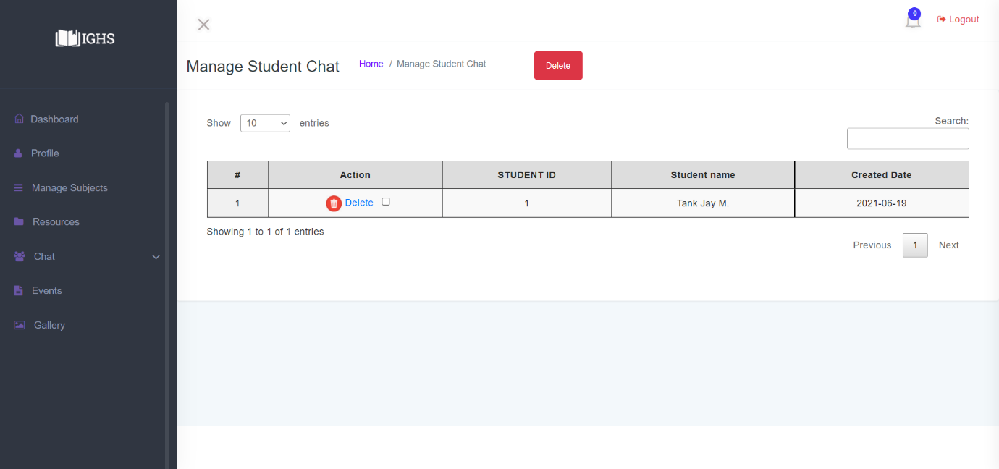

**Image-9.10**

**Student : Panel**

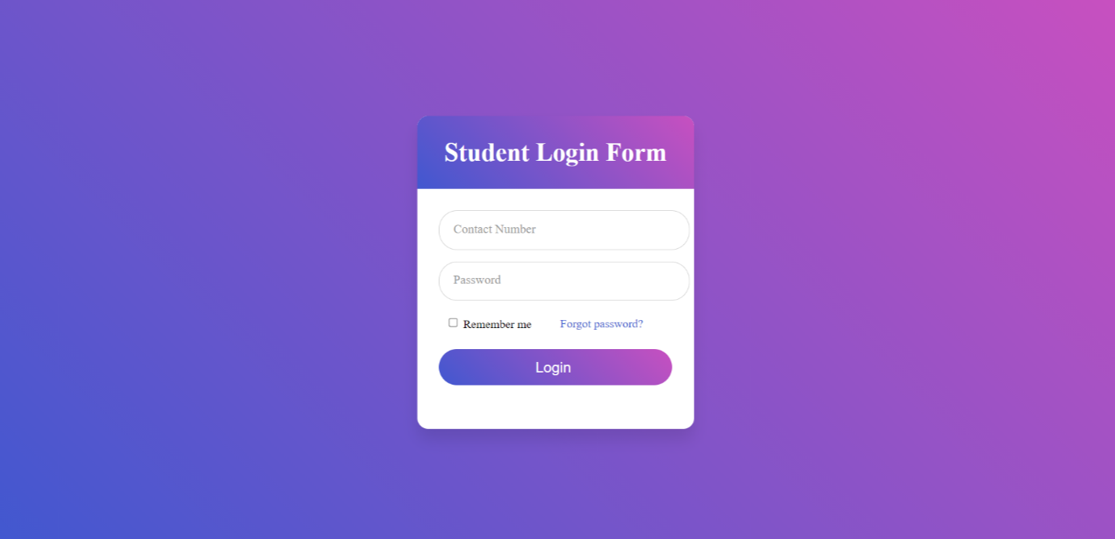

**Image-10**

**Student : Main Window**

* In main window Student can see a image slider with school's Images and access other features as listed below : -
  + Downloads Resources : Students can download Resources uploaded by their subject teacher .
  + Gallery : Students can access Gallery images uploaded by admins.
  + Profile : Students can access their own profiles and change password.
  + Chat : Students can message any teacher to solve their queries.
  + Notification : Students can receive notification from admin .

and its snapshots are as below :-

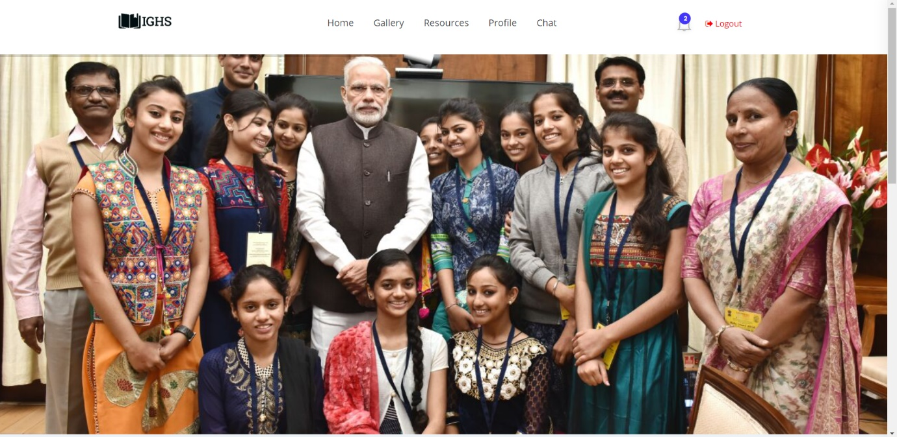

**Image-10.2**

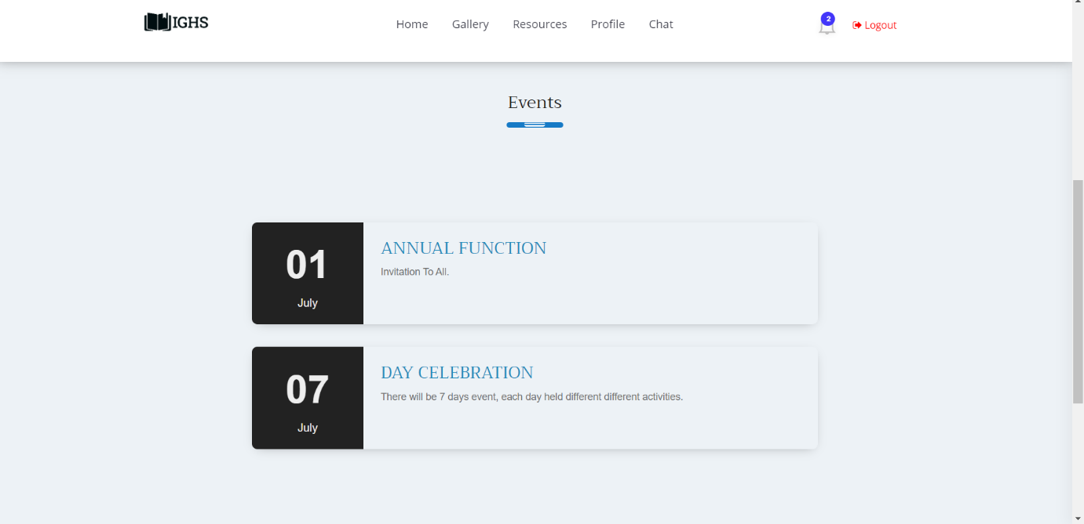

**Image-10.2.1**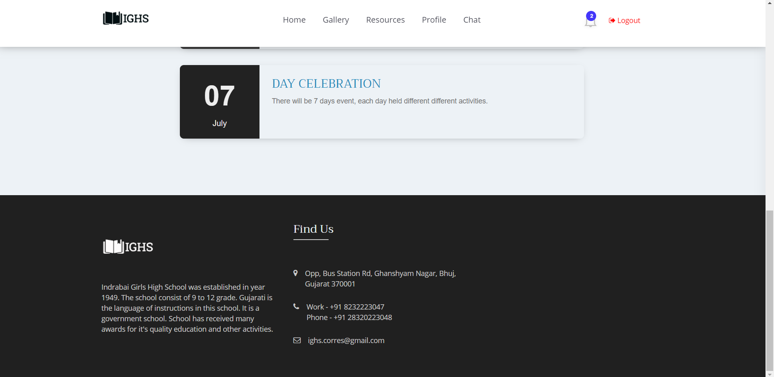

**Image-10.2.2**

**Student :Notification**

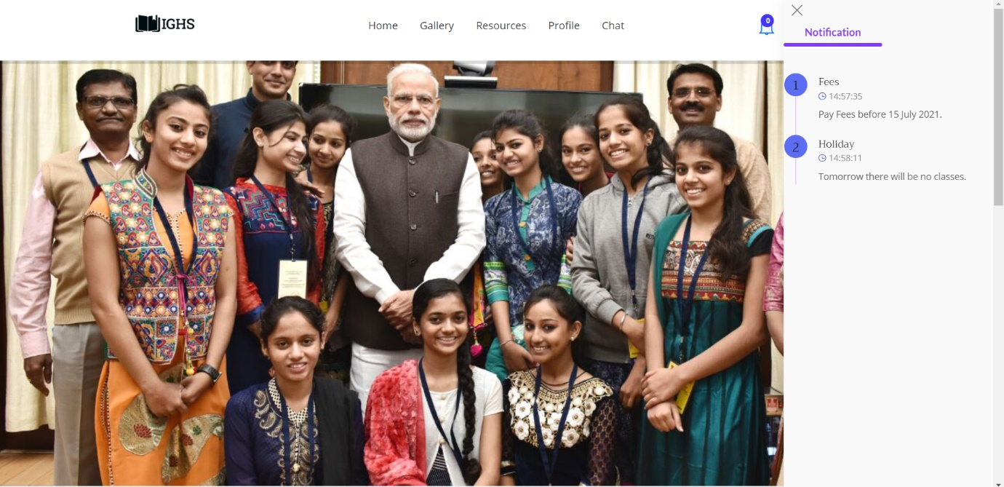

**Image-10.3**

**Student : Profile**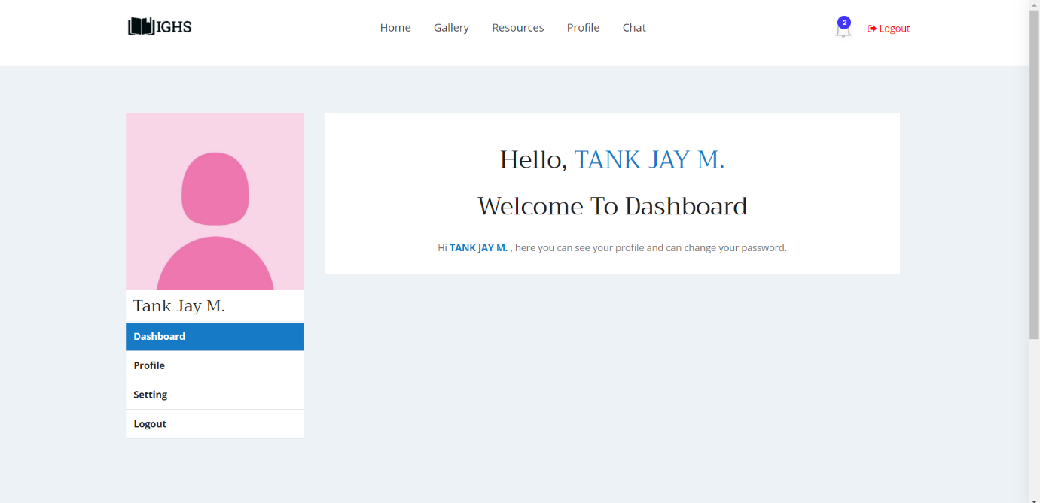

**Image-10.4**

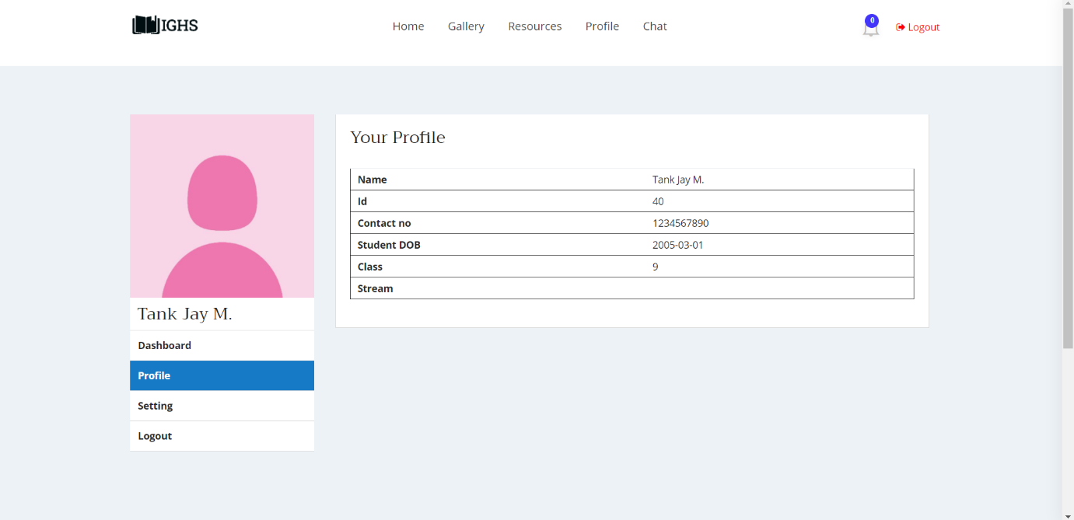

**Image-10.4.1**

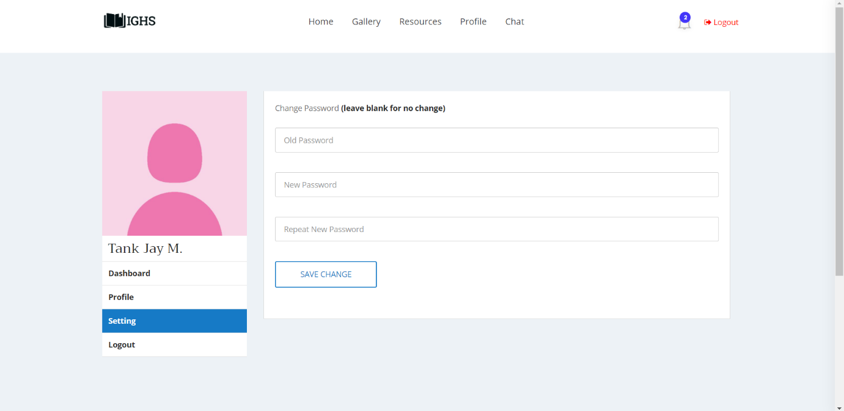

**Image-10.4.2**

**Student : Download Resources**

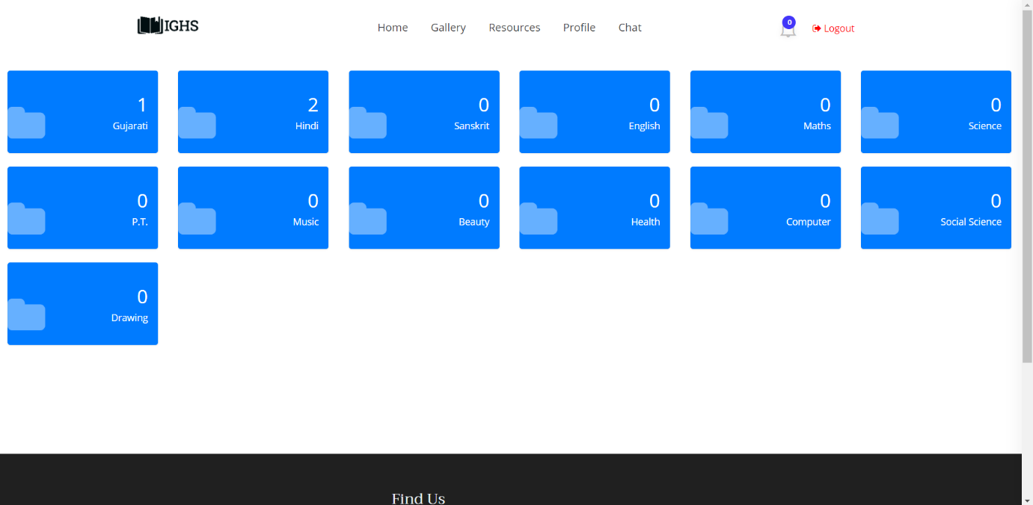

**Image-10.5**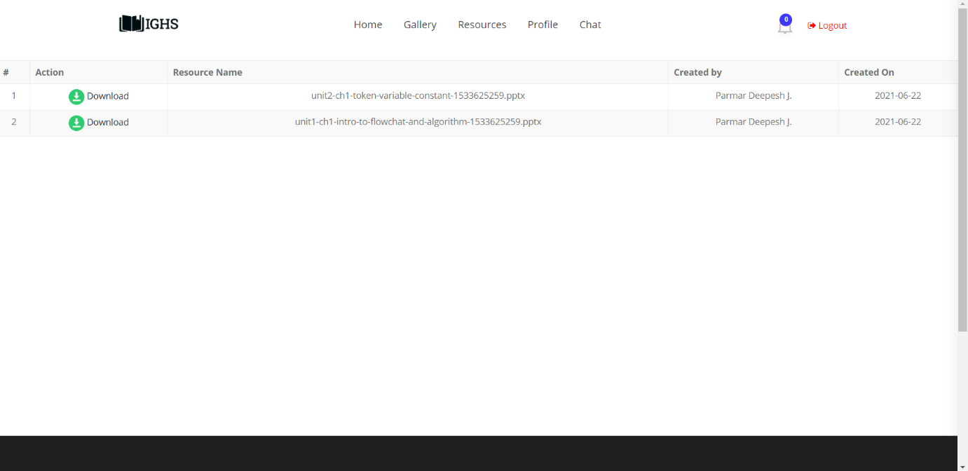

**Image-10.5.1**

**Student :Gallery**

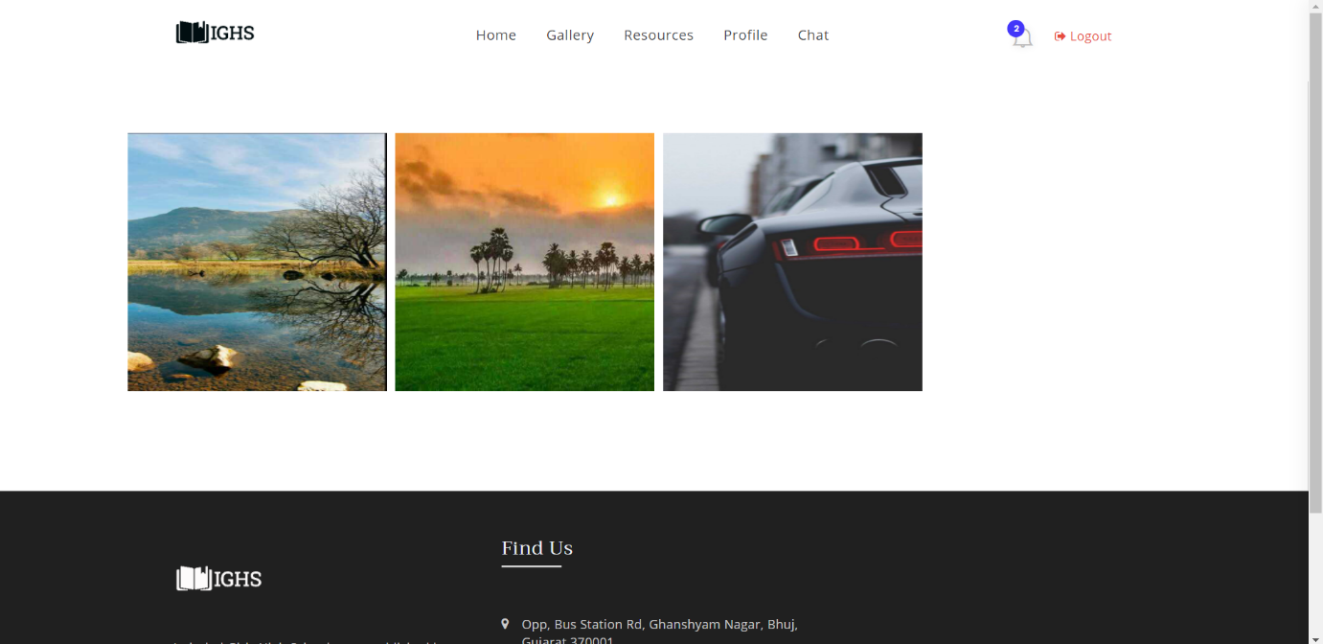

**Image-10.6**

**Student : Chat**

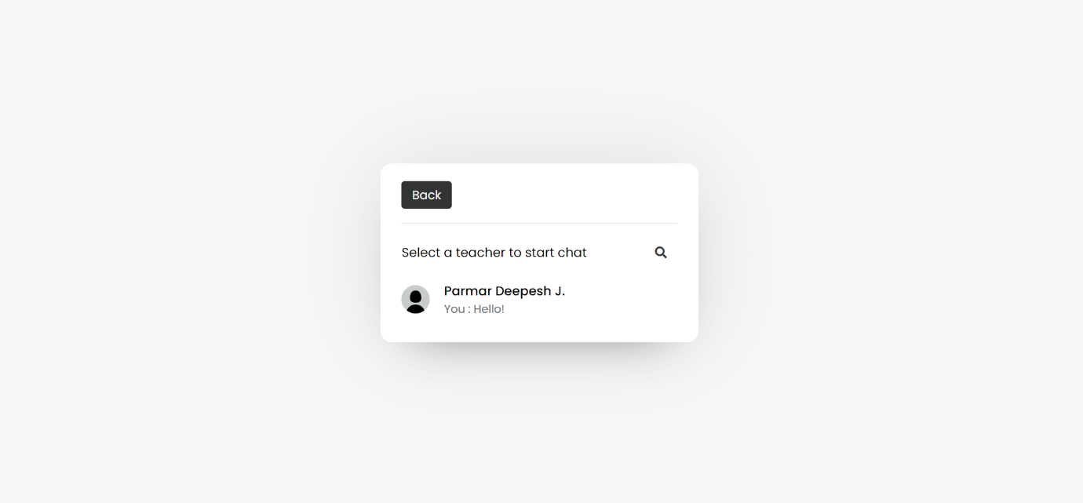

**Image-10.7**

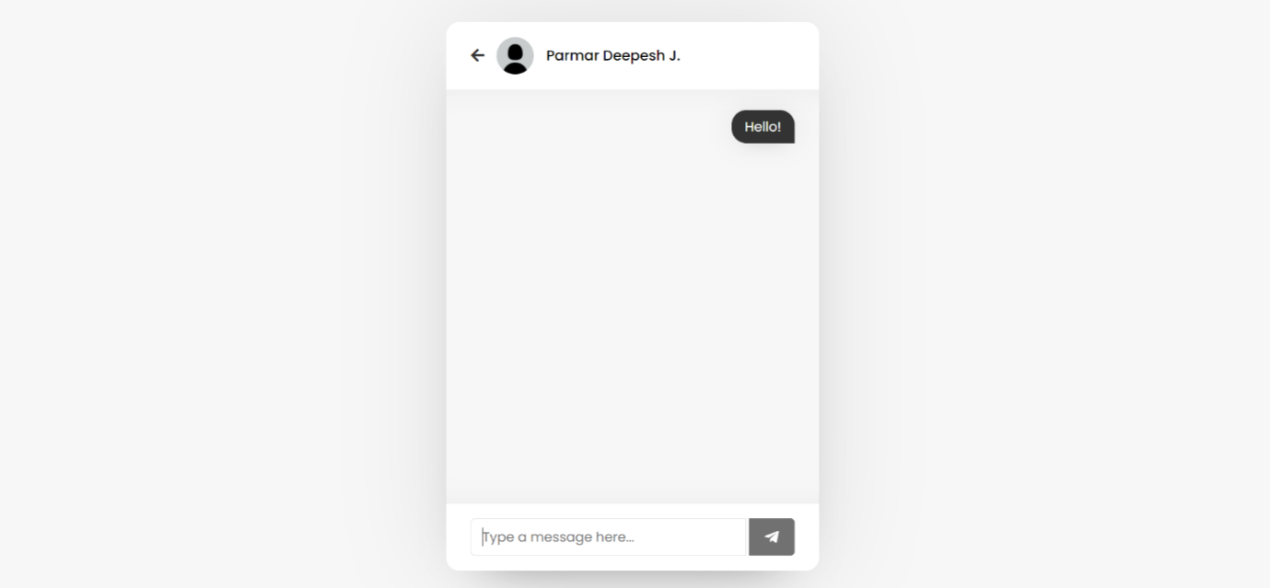

**Image-10.8**

**admin**

|  |  |  |  |
| --- | --- | --- | --- |
| **Column** | **Type** | **Null** | **Default** |
| A_id *(Primary)* | bigint(20) | No |  |
| A_Photo | varchar(50) | Yes | *NULL* |
| A_name | varchar(60) | No |  |
| A_mobile | varchar(10) | No |  |
| A_address | varchar(255) | No |  |
| A_password | varchar(50) | No |  |
| is_deleted | tinyint(1) | No |  |
| A_dob | date | No |  |
| Created_on | date | No | curdate() |
| Created_by | bigint(20) | No |  |
| notification_count | int(20) | No |  |

**Class**

|  |  |  |
| --- | --- | --- |
| **Column** | **Type** | **Null** |
| Class_id *(Primary)* | bigint(20) | No |
| C_no | int(11) | No |
| Stream | varchar(40) | No |

**conversation**

|  |  |  |  |  |
| --- | --- | --- | --- | --- |
| **Column** | **Type** | **Null** | **Default** | **Links to** |
| chat_id | bigint(20) | No |  |  |
| chat_text | varchar(255) | No |  |  |
| Created_on | date | No | curdate() |  |
| S_srn | bigint(20) | No |  | students ->S_srn |
| T_srn | bigint(20) | No |  | teachers ->T_srn |
| is_c_deleted | tinyint(1) | No |  |  |
| sender_type | varchar(10) | No |  |  |

**event**

|  |  |  |  |  |
| --- | --- | --- | --- | --- |
| **Column** | **Type** | **Null** | **Default** | **Links to** |
| Sr_n *(Primary)* | bigint(20) | No |  |  |
| Event_topic | varchar(120) | No |  |  |
| Event_text | varchar(120) | No |  |  |
| is_deleted | tinyint(1) | No |  |  |
| disabled | tinyint(1) | No | 0 |  |
| Created_on | date | No | curdate() |  |
| event_date | date | No |  |  |
| created_by | bigint(20) | No |  | admin ->A_id |

**images**

|  |  |  |  |  |
| --- | --- | --- | --- | --- |
| **Column** | **Type** | **Null** | **Default** | **Links to** |
| Id *(Primary)* | bigint(20) | No |  |  |
| Image | varchar(255) | No |  |  |
| Uploaded_by | bigint(20) | No |  | admin ->A_id |
| Uploaded_on | date | No | curdate() |  |

**log**

|  |  |  |  |
| --- | --- | --- | --- |
| **Column** | **Type** | **Null** | **Default** |
| Sr_n *(Primary)* | bigint(20) | No |  |
| L_Date | date | No | curdate() |
| L_Time | time | No | current_timestamp() |
| Name | varchar(100) | No |  |
| Authority | varchar(10) | No |  |
| Contact | varchar(10) | No |  |
| Action | varchar(255) | No |  |
| Status | text | No |  |
| IP_address | varchar(35) | No |  |
| City | varchar(100) | No |  |
| Region | varchar(100) | No |  |
| Country | varchar(100) | No |  |

**notification**

|  |  |  |  |  |
| --- | --- | --- | --- | --- |
| **Column** | **Type** | **Null** | **Default** | **Links to** |
| Sr_n *(Primary)* | bigint(20) | No |  |  |
| Notification_topic | varchar(120) | No |  |  |
| Notification_text | varchar(120) | No |  |  |
| is_deleted | tinyint(1) | No |  |  |
| Created_on | date | No | curdate() |  |
| N_Time | time | No | current_timestamp() |  |
| created_by | bigint(20) | No |  | admin ->A_id |
| n_status | tinyint(1) | No |  |  |

**resources**

|  |  |  |  |  |
| --- | --- | --- | --- | --- |
| **Column** | **Type** | **Null** | **Default** | **Links to** |
| R_id *(Primary)* | bigint(20) | No |  |  |
| R_path | varchar(250) | No |  |  |
| Created_on | date | No | curdate() |  |
| Created_by | bigint(20) | No |  | teachers ->T_srn |
| Sub_id | bigint(20) | No |  | subjects ->Sub_id |
| is_deleted | tinyint(1) | No | 0 |  |

**students**

|  |  |  |  |
| --- | --- | --- | --- |
| **Column** | **Type** | **Null** | **Default** |
| S_srn *(Primary)* | bigint(20) | No |  |
| S_photo | varchar(50) | Yes | *NULL* |
| S_grn | int(5) | No |  |
| S_uidn | varchar(18) | No |  |
| S_name | varchar(50) | No |  |
| S_caste | varchar(50) | No |  |
| S_category | varchar(50) | No |  |
| S_dob | date | No |  |
| S_contact | varchar(10) | No |  |
| S_ad_date | date | No |  |
| Class_id | bigint(20) | No |  |
| S_adharn | varchar(12) | No |  |
| S_hostel | varchar(80) | No |  |
| S_home | varchar(80) | No |  |
| S_handicapped | varchar(5) | No |  |
| S_describe | varchar(80) | No |  |
| S_password | varchar(50) | No |  |
| S_remarks | varchar(50) | No |  |
| Academic_year | varchar(15) | No |  |
| is_deleted | tinyint(1) | No |  |
| Created_on | date | No | curdate() |
| s_status | varchar(20) | No |  |
| updated | int(2) | No |  |
| notification_count | int(20) | No |  |

**subjects**

|  |  |  |  |
| --- | --- | --- | --- |
| **Column** | **Type** | **Null** | **Links to** |
| Sub_id *(Primary)* | bigint(20) | No |  |
| Sub_name | varchar(40) | No |  |
| Class_id | bigint(20) | No | class ->Class_id |

**teachers**

|  |  |  |  |
| --- | --- | --- | --- |
| **Column** | **Type** | **Null** | **Default** |
| T_srn *(Primary)* | bigint(20) | No |  |
| login_count | int(11) | No |  |
| T_photo | varchar(50) | Yes | *NULL* |
| T_name | varchar(50) | No |  |
| DOB | date | No |  |
| Degree | varchar(50) | No |  |
| A_date | date | No |  |
| Joining_date | date | No |  |
| Retire_date | date | No |  |
| Contact | varchar(10) | No |  |
| Password | varchar(50) | No |  |
| is_deleted | tinyint(1) | No |  |
| Created_on | date | No | curdate() |
| t_status | varchar(20) | No |  |
| notification_count | int(20) | No |  |

**teacherstd**

|  |  |  |
| --- | --- | --- |
| **Column** | **Type** | **Null** |
| ts_id *(Primary)* | bigint(20) | No |
| id_sub | int(11) | No |
| id_teacher | int(11) | No |
| is_deleted | tinyint(1) | No |

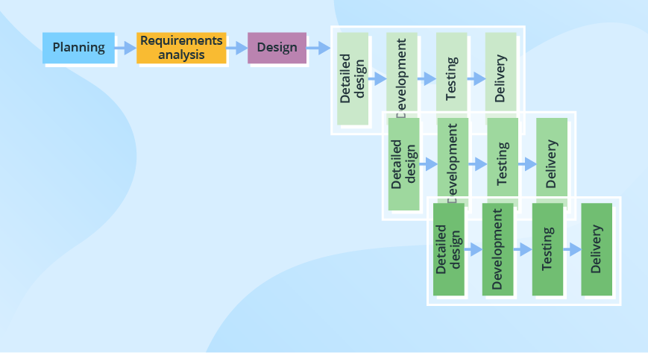

We are going to use Iterative model for our project

WHY Iterative model??

1. Testing and debugging during smaller iteration is easy.

2. A Parallel development can plan.

3. It is easily acceptable to ever-changing needs of the project.

4. Risks are identified and resolved during iteration.

5. Limited time spent on documentation and extra time on designing.

In our project we have multiple modules so if there is a need to change in a particular module, then a new version of that module will be created with a new iteration. By this method

our project will be well synchronized.

Develepment tools and Technology used

Front end tools :

HTML, CSS , JavaScript, Bootstrap 4, Ajax with xml

Backend Tools : PHP (version 8.0.1), MYSQL (version 8.0).

Cascading Style sheets (CSS)

Cascading Style sheets (CSS) is a style sheet language used for describing the presentation of a document written in a markup language like HTML. CSS is a cornerstone technology of the World Wide Web, alongside HTML and JavaScript. CSS is to designed to enable the separation of presentation and content. Including layout, colours and fonts.

This separation can improve content accessibility. Provide more flexibility and control in the specification of presentation characteristics. Enable multiple web pages to share formatting by specifying the relevant CSS in a separate .css file, and reduce complexity and repetition in the structural content

JavaScript

JavaScript is a high level, dynamic, untyped, and interpreted programming language. It has been standardized in the ECMAScript language specification. Alongside HTML and CSS, it is one of the three essential technologies of World Wide Web content production; the majority of websites employ it and it is supported by all modern web browsers without plug-ins.

JavaScript is prototype-based with first-class functions, making it a multi-paradigm language, supporting object-oriented, imperative, and functional programming styles.

It has an API for working with text, arrays, dates and regular expressions, but does not include any I/O, such as networking, storage or graphics facilities, relying for these upon the host environment in which it is embedded.

BOOTSTRAP 4

* Bootstrap is the most popular HTML, CSS and JavaScript framework for developing a responsive and mobile friendly website.
* It is absolutely free to download and use.
* It is a front-end framework used for easier and faster web development.
* It includes HTML and CSS based design templates for typography, forms, buttons, tables, navigation, modals, image carousels and many others.
* It can also use JavaScript plug-ins.
* It facilitates you to create responsive designs.

jQuery

jQuery is a fast, small, and feature-rich JavaScript library. It makes things like HTML document traversal and manipulation, event handling, animation, and Ajax much simpler with an easy-to-use API that works across a multitude of browsers. With a combination of versatility and extensibility, jQuery has changed the way that millions of people write JavaScript. jQuery is a lightweight, "write less, do more", JavaScript library. The purpose of jQuery is to make it much easier to use JavaScript on your website. jQuery takes a lot of common tasks that require many lines of JavaScript code to accomplish, and wraps them into methods that you can call with a single line of code. jQuery also simplifies a lot of the complicated things from JavaScript, like AJAX calls and DOM manipulation. The jQuery library contains the following features:

• HTML/DOM manipulation

• CSS manipulation

• HTML event methods

• Effects and animations

• AJAX

• Utilities

AJAX with XML

AJAX is an acronym for Asynchronous JavaScript and XML. It is a group of inter-related technologies like JavaScript, DOM, XML, HTML/XHTML, CSS, XMLHttpRequest etc.

AJAX allows you to send and receive data asynchronously without reloading the web page. So it is fast. AJAX allows you to send only important information to the server not the entire page. So only valuable data from the client side is routed to the server side. It makes your application interactive and faster.

ABOUT PHP

PHP is a widely-used open-source general-purpose scripting language that is especially suited for web development and can be embedded into HTML. Created by Rasmus Lerdorf in 1994. PHP originally stood for Personal Home Page but in now stands for the hypertext pre-processor. PHP has been widely ported and can be deployed on most web servers on almost every operating system and platform.

What’s new in php version 8.0.1

PHP 8.0.1 is a major version update and a remarkable milestone in PHP, as it brings several new features to type system, syntax, error handling, strings, object-oriented programming, and more. It is the efforts of hundreds of people coming together to shape the future of a programming language that powers a significant portion of the Internet web sites and applications.

PHP tries to be conservative with changes that can break a majority of the applications, and yet, it brings several new major features to PHP 8.0.1. Features such as Named Parameters, JIT, Attributes, and Constructor Properties bring major improvements and syntax changes, while several minor improvements such as resource to object migrations, improved error handling, and changes and improvements in operators and engine comparisons help seamlessly reduce the chances of overlooked bugs.

About MySQL

MySQL is an open-source relational database management system (RDBMS). Major Features of MySQL:

• Stored procedure

• Triggers

• Cursors

• Updatable views

• Query caching

• Sub-Select (i.e. nested Selects)

• Embedded database library Commit grouping, gathering multiple transaction from multiple connections together.

phpMyAdmin

phpMyAdmin is a free and open source tool written in PHP intended to handle the administration of MySQL with the use of a web Browser. It can perform various tasks such as creating, modifying or deleting databases, tables, fields or rows, executing SQL statements, or managing users and permission.

Features: Import data from CSV and SQL Export data to various format: CSV, SQL, XML, PDF. Creating complex queries using Query-by-Example (QBE) Searching globally in database or subset of it.

Proposed Enhancement

Limitations :

1. This website is designed only for the particular school so only students and staff can login to this website.
2. We can't send images as a resource file.
3. Students and Teachers can't change their personal data by themselves they have to contact admin for that.
4. Students & Teachers get their notifications and details about events only if they login to website.

Future Enhancement:

* + - 1. Push notifications via web browser
      2. Sending images on chat box.
      3. Online offline feature with firebase.
      4. Taking attendance of students.
      5. Getting Results of students.
      6. Time table which can be changed by admin.

Bibliography

* <https://www.jqueryscript.net/form/Easy-DragnDrop-AJAX-Uploader-Plugin-For-jQuery-ssi-uploader-js.html>
* <https://www.campcodes.com/projects/php/4709/online-student-result-management-system-in-php-mysqli/>
* <https://elements.envato.com/educo-elearning-education-html-template-AJ3BKZ9>
* <https://youtu.be/VnvzxGWiK54>
* <https://phpspreadsheet.readthedocs.io/en/latest/>
* <https://datatables.net/>